|  |  |
| --- | --- |
| **PRACTICAL ASSESSMENT** | **Uncontrolled when printed**  **16/12/2014**  **FM02_21b** |

|  |  |  |  |  |  |  |  |  |  |  |
| --- | --- | --- | --- | --- | --- | --- | --- | --- | --- | --- |
| **Student Name:** | | | **Angelo Palazzolo** | | | **Student Number:** | | | **3150704699** | |
| **Unit Code/s & Name/s:** | | | ICAWEB505A: Develop Complex web page layouts  ICAWEB506A: Develop complex cascading stylesheets | | | | | | | |
| **Assessment Description:** | | | P1 | | | | | | | |
| **Assessment Due Date:** | | |  | | **Assessment Received Date:** | | | | |  |
| **Student Declaration:** I declare that this assessment is my own work. Any ideas and comments made by other people have been acknowledged as references. I understand that if this statement is found to be false, it will be regarded as misconduct and will be subject to disciplinary action as outlined in the TAFE Queensland Student Rules. I understand that emailing or submitting this assessment electronically confirms my assent to this declaration in lieu of a written signature. | | | | | | | | | | |
| **Student Signature:** | |  | | | | | **Date: / /** | | | |
| **Assessor Feedback:**  **Student provided with feedback** | | | | | | | | | | |
| **Attempt 1 Satisfactory  Not Satisfactory  Date:      /     /** | | | | | | | | | | |
| **Attempt 2 Satisfactory  Not Satisfactory  Date:      /     /** | | | | | | | | | | |
| **Assessor Name:** |  | | | **Assessor Signature:** | | | |  | | |
| **Note to assessor: Please record any adjustment below that has occurred to this assessment e.g. Oral questions were used to support student’s ability to complete tasks identified.** | | | | | | | | | | |
|  | | | | | | | | | | |
| **Disclaimer:** TAFE Queensland North (TQN) is collecting the information on this form for assessment purposes. Only authorised Departmental officers have access to this information. Your personal information will not be disclosed to any other third party without your consent, unless authorised or required by law, in accordance with the Information Privacy Act 2009. | | | | | | | | | | |

**This section must be completed by the student when the student either posts or hands a completed assessment/assignment to customer service centres. a receipt is only issued for face to face assessments when requested by the student.**

✀ **RECEIPT**

|  |  |  |
| --- | --- | --- |
| STUDENT TO COMPLETE |  | OFFICE USE ONLY |
| Unit of competency code/s:__________________ |  |  |
| Assessment item/No: ______________________ |  | Date received: / / |
| Student’s name: __________________________ |  |  |

|  |  |
| --- | --- |
| **Instructions to Student:** | **Time allowed:** This assessment is to be completed over the semester.  **Materials and equipment to be supplied by the Student:**   * Access to a PC, Web Authoring Tools, web server and hosting.   **General Instructions:**   * You will need access to the AllStyles Design Brief * You have 3 tasks to complete. * You will need to answer **all** questions correctly * Keep a copy of all assessments as you will be required, to submit them as a zipped file to your teacher.   NOTE: If you are not successful on your first attempt, you will be given comments and a further two weeks to rectify the changes.  You will need to re-submit your corrections for remarking. If you are unsuccessful on your second attempt, you will be required to re-enrol in this unit. |
| **Instructions to Assessor:** | Please see Instructions to Student above. |
| **Assessment Context and Description: (if required)** | In order to gain competency in ICAWEB505A: Develop Complex web page layouts, successful completion is required of the following assessments items:   * Practical Assessment |
| **Note to Student:** | An Assessment Matrix is available from your teacher upon request. The matrix shows how the knowledge and skills that you are being asked to demonstrate align to the Elements, Performance Criteria, Critical Aspects, Required Skills and Required Knowledge components of each Unit of Competency. |

For this task you will need to review the client requirements from the design brief. You will need to document the following to be included in your report:

1. identify the main sections of the page for layout
2. create an appropriate file / folder structure for the site
3. develop a naming convention for files

**Project**

For this project you need to develop a client website according to the given design brief. The site is to be laid out, styled and formatted using advanced CSS. (If you would like to use a different design brief, this will need to be discussed with your teacher for approval prior to completing this assessment, you will be required to do additional work.)

You will need to create a new folder called '**complex_webpages**' and save all files in this folder. You should create sub folders as necessary.

## Task 1 - review site requirements

***For this task you will need to review the client requirements from the design brief.***

Online Systems Solutions was chosen to develop and produce an effective website which addressed the client’s requirements expressed in the design brief. It is important to note that to this point of time AllStyle Homes had no existing website, and as such the proposed website is being developed following detailed discussions with the clients during which time their needs and expectations were identified and the design brief was developed.

The General Requirements of the client were specific:

* Develop a web presence
* Function as a marketing and sales tool
* Increase company profile, nationally and internationally
* Reduce traditional advertising costs
* Streamline sales
* Means of obtaining feedback from customers, both retail and wholesale

The Functional Requirements, were equally specific

* Site to contain eight (8) pages; these being – Home, About, Designs, Our Processes, FAQ, Testimonials, Contact and Privacy. It is acknowledged additional pages may be required to accommodate and organise relevant information. Briefly, ech page would contain the following information:

|  |  |
| --- | --- |
| Page | Contents |
| Home | Introduction and welcome. |
| About | General information about the business |
| Designs | An overview of the standard house designs available. This page should also include an imagemap type document highlighting each of the areas as detailed in the section titled “Imagemap” |
| Our Process | This page should contain information about the building process. |
| FAQ | Containing details answering common questions asked by clients of the business. |
| Testimonials | A page containing testimonials from previous clients |
| Contact | This page should give all contact details for ‘AllStyle Homes’. |
| Privacy | Should contain a privacy statement |

* Each page should contain the following elements
  + Company Logo – provided to us by the company in both a ‘jpg’ and ‘png’ formats
  + Company Slogan “Your tick of approval is our guarantee”
  + Domain – [www.allstylehomes.com.au](http://www.allstylehomes.com.au)
  + Copyright statement – “© 2012 AllStyle Homes”
* Each page should be presented with the following layout

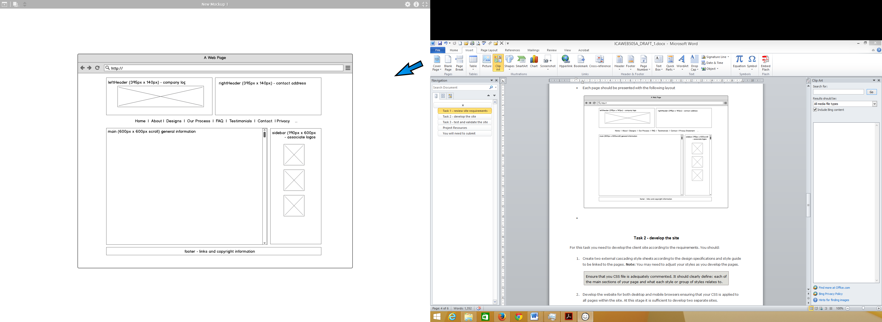

Figure : Wireframe mock-up of the desktop (res: > 801px)

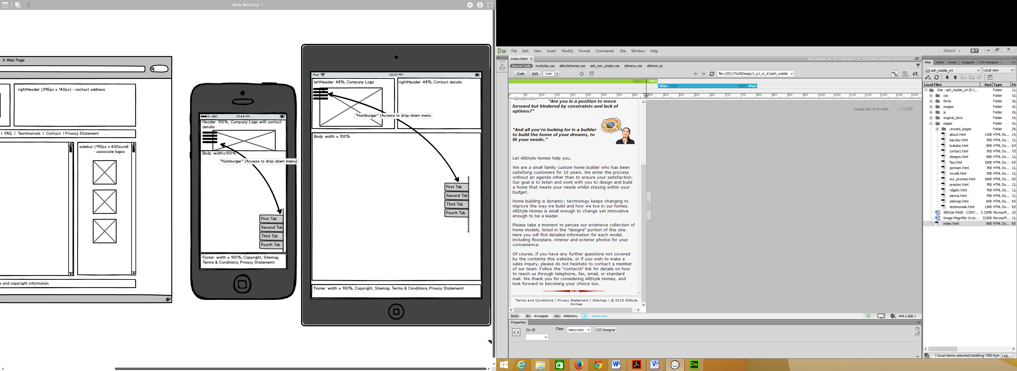 

Figure : Wireframe for Tablet (res: >480 & < 801px). Figure : Wireframe for Phone (res: < 481px)

* The website should adhere to the following guidelines which should be read in conjunction with the diagram above:

|  |  |
| --- | --- |
| **Note:** All styles should be implemented using CSS and NOT HTML tags | |
| Corporate colours | The AllStyle Homes corporate colors (as seen in the company logo) should be utilized for this site and selected from the list below:    These colours can be adjusted to suit visibility and contrast requirements if necessary. |
| Page layout | The mock-up image gives an indication as to the general layout of the page. The page content should be centred on the screen. The overall page background colour should be a light grey (#DFDFDF)  The main content background colour should be off-white (#F6F6F6). Other background colours, in keeping with the corporate colours, can be used in other sections of the site where appropriate. |
| Text | All text should be rendered in the following font set:  Verdana, but allowed to degrade to Arial, Helvetica, sans-serif.  All paragraph text should be left aligned and to the following specifications (***you may use line and word spacing for paragraphs as you deem appropriate***): |
| Hyperlinks | All hyperlink text should be rendered in the following font set:  Verdana, but allowed to degrade to Arial, Helvetica, sans-serif.  Hyperlinks should not be underlined except where specified. |
| Footer Hyperlinks | Footer hyperlinks should be rendered in the following font set:  Tahoma, but allowed to degrade to Geneva, sans-serif  The footer area should also contain a text menu (centred within the footer area) with each item separated by the | (pipe) character and with the following link specifications: |
| Images | Text should be appropriately aligned around images. |

The Technical Requirements were as follows:

|  |  |  |
| --- | --- | --- |
| **Element** | **Requirement** | **Example** |
| File naming convention | All lowercase alphanumeric up to 20 characters  Three/Four letter file type extensions  No spaces, an underscore for separation | jannsen_sm.jpg process.html  media_queries.css  ddmenu.js privacy_statement.pdf |
| Folder naming convention | Folders should be named to represent the contents of the folder eg: images  All lowercase up to 20 characters  No spaces, an underscore for separation | css pages images documents js |
| Browser compatibility | Internet Explorer 7+  Mozilla Firefox 10+  Google Chrome 17+ | [if lt IE 8]> ~ <![endif]  -moz- ; -ms- ; -webkit- |
| Browser plug-ins | No specific browser plug-ins required at this stage | Nil |
| File format to be used | Image files should be .gif, .jpg or .png as appropriate.  Pages should be .html | Images: .png & .jpg  Pages: html |
| Document formats | All documents should be provided in PDF format | privacy_statement.pdf terms_and_conditions.pdf |
| Page download times | < 10 secs at 256kbps | Yes |
| Default screen resolution | 1024 x 768 pixels | Yes |
| Content accessibility | W3C Content Accessibility Guidelines 2.0 (WCAG 2.0) Level A  W3C Cascading Style Sheets Level 2 Revision 1 (CSS2.1) minimum | http://www.w3.org/TR/WCAG/  http://www.w3.org/TR/CSS2/ |
| Target Hardware | Systems capable of running these OS:  Windows XP and above  Apple Mac OS X | Yes |

**Folder Structure**

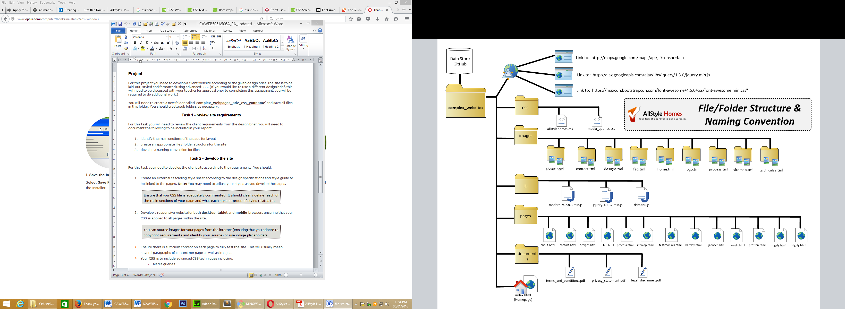

Figure : Graphical representation of the website folder structure and the files contained within.

## Task 2 - develop the site

1. ***Create an external cascading style sheet according to the design specifications and style guide to be linked to the pages. Note: You may need to adjust your styles as you develop the pages.***

Two external style sheets were uses in the website

* allstylehomes.css – This style sheet contained coding for all elements in the website which will be viewed on a computer monitor or device with a resolution greater than 800 pixels
* media_queries.css – This style sheet contained coding for all elements in the website which will be viewed on a tablet (or device) with a resolution greater than 400 and less than 801 pixels AND smartphone (or device) with a resolution less than 401pixels

Within both style sheet, commenting (/* */) was used to define both the different sections within which coding was grouped and for specific lines of code

***2. Develop a responsive website for both desktop, tablet and mobile browsers ensuring that your CSS is applied to all pages within the site.***  
Advanced CSS techniques were included to enhance the functionality and aesthetic appeal of the site

**Media Queries:** Media Queries have been used to enable the website to transition easily between display devices. The following Media Queries have been configured:

* @media (min-width: 481px) and (max-width: 801px) - for tablet-sized screen resolutions that fit between 481 pixels and 801 pixels, and
* @media (max-width: 480px) - for small, smartphone type screen resolutions

Both of these Media Queries are located in a single CSS file called “media_queries.css” located in a folder called “css”. Within each of these queries, the CSS code is modified to enable the page content to function and appear at its correct and optimal level for the respective device

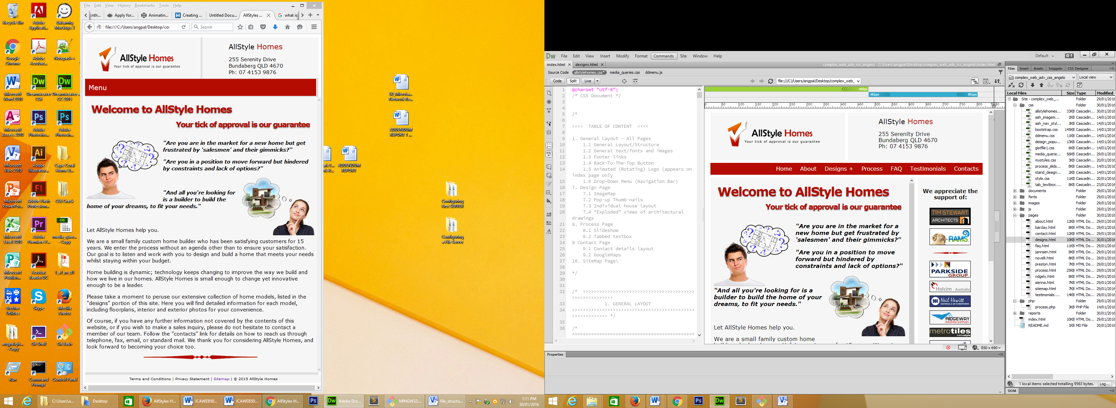

Figure : Above: No media query required for computer screen resolution greater than 801pixels.

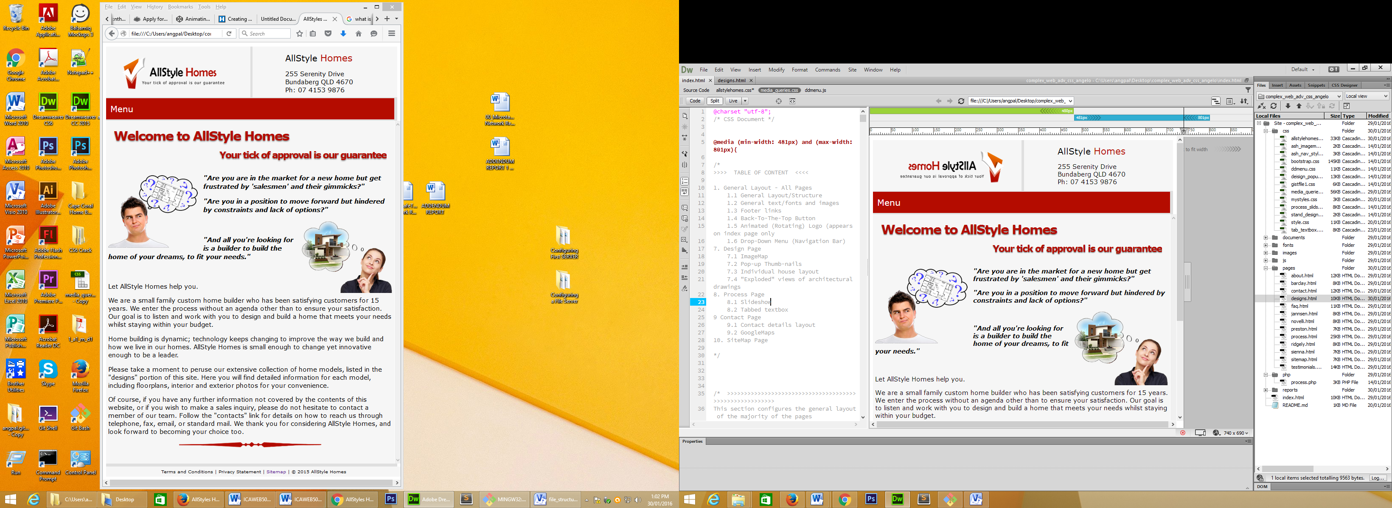

Figure : Above: Media query (left) set for mid-sized screens, with resolution between 481pixels and 801pixels.

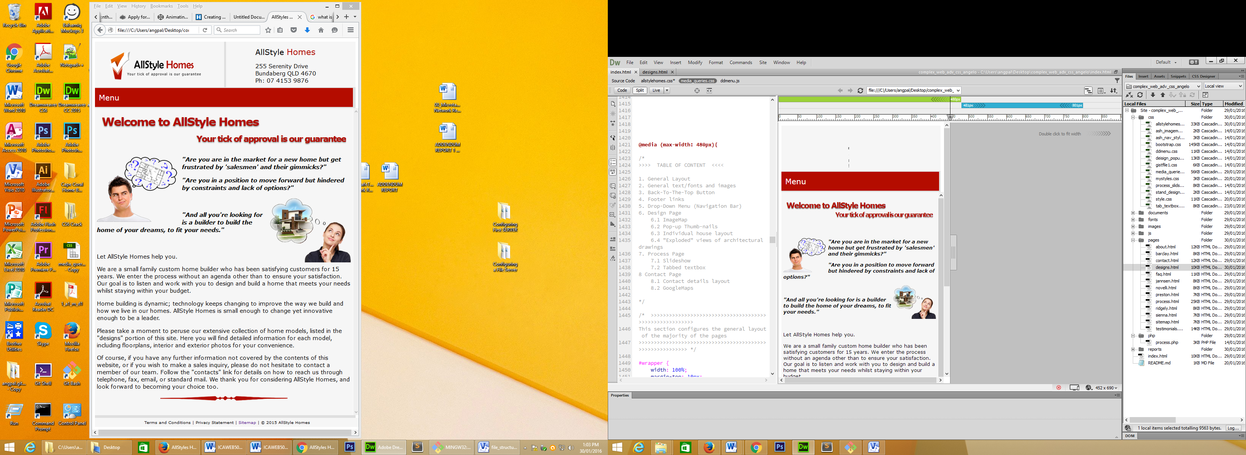

Figure : Above: The media query (left) has be set for small, mobile displays with a resolution less than 481pixels.

**2D Animation:** CSS code has been used within this site to animate many HTML elements (such as div, class h1 and span) without JavaScript or Flash. Unfortunately not all web browsers (more accurately, older versions of browsers) are capable of “running” such code. To compensate for that, appropriate vendor prefixes have been included in the CSS code.

Each animated element has been made up a combination of HTML, standard CSS and specific animation CSS. With respect to the last of these, each animation has been defined with the “@keyframes *name-of-animation”* which is then called with the animation property. Each “@keyframes *name-of-animation*” defines what happens at specific moments during the animation. For example, 0% is the beginning of the animation and 100% is the end.

There are two examples of 2D animation using CSS within the website. Example 1 (below): Company logo on the homepage is set to make one revolution when page opens. Top-Left: CSS sets animation name "spinner", sets the iterations and duration. Bottom-Left: Keyframe called "spinner" sets the action to rotation from 0deg to 360deg.

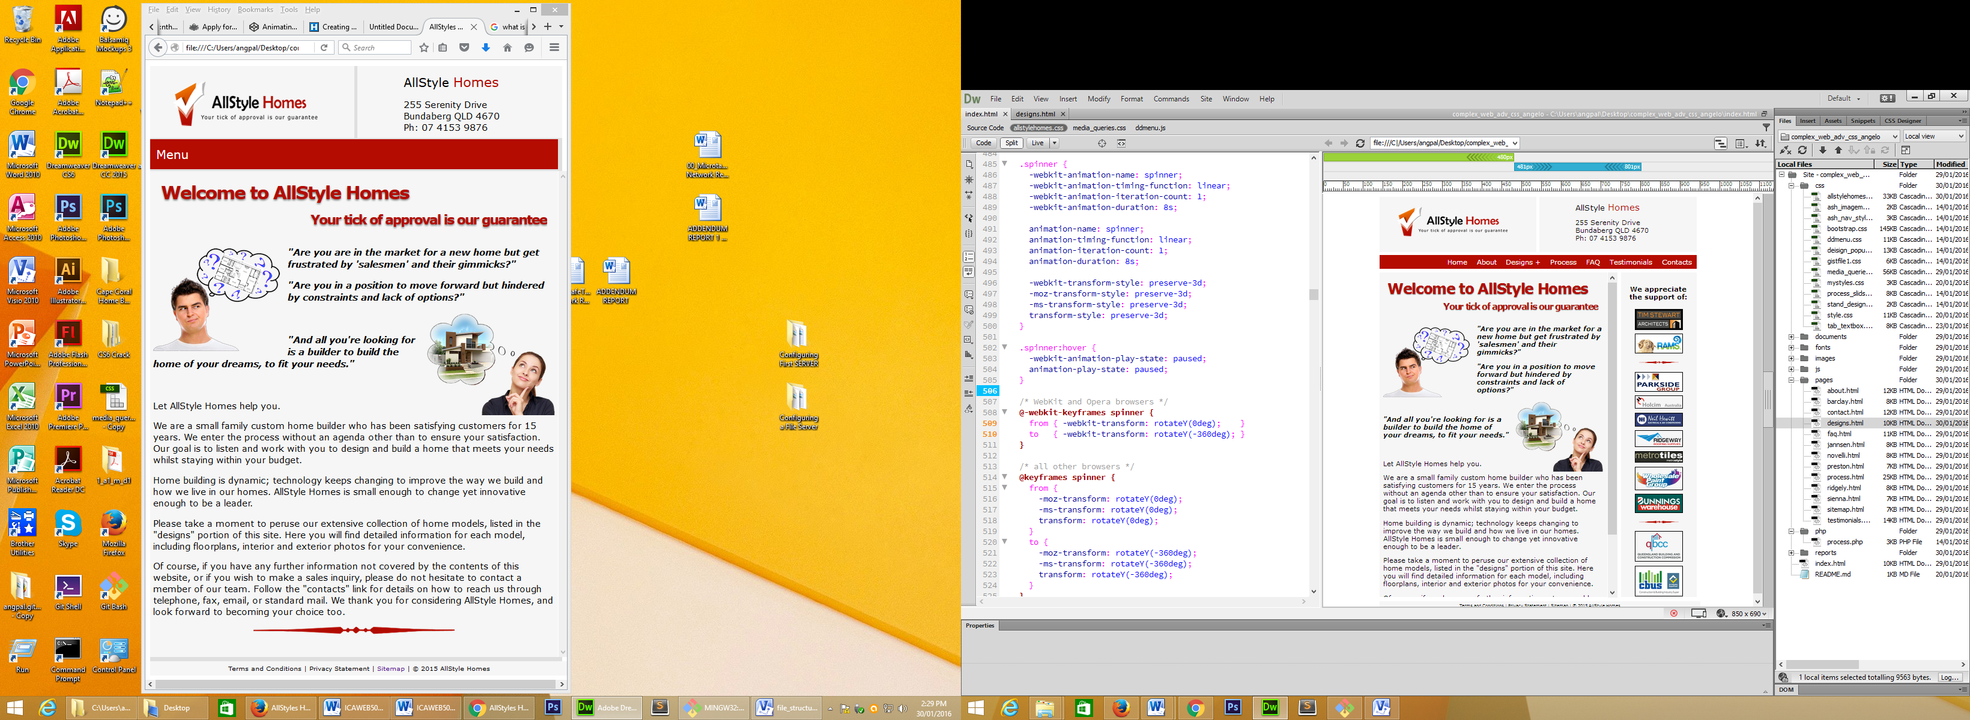

Figure : Example 1 – Company logo makes 1 revolution when page opens up.

Example 2 (below): The main heading has been animated into a marque comprised of two sentences that slide in/out. The CSS (left) sets animation names, duration & iterations and the keyframes (centre) specify movement on/off screen based on a percentage of its length and its location is specified as a percentage of total duration.

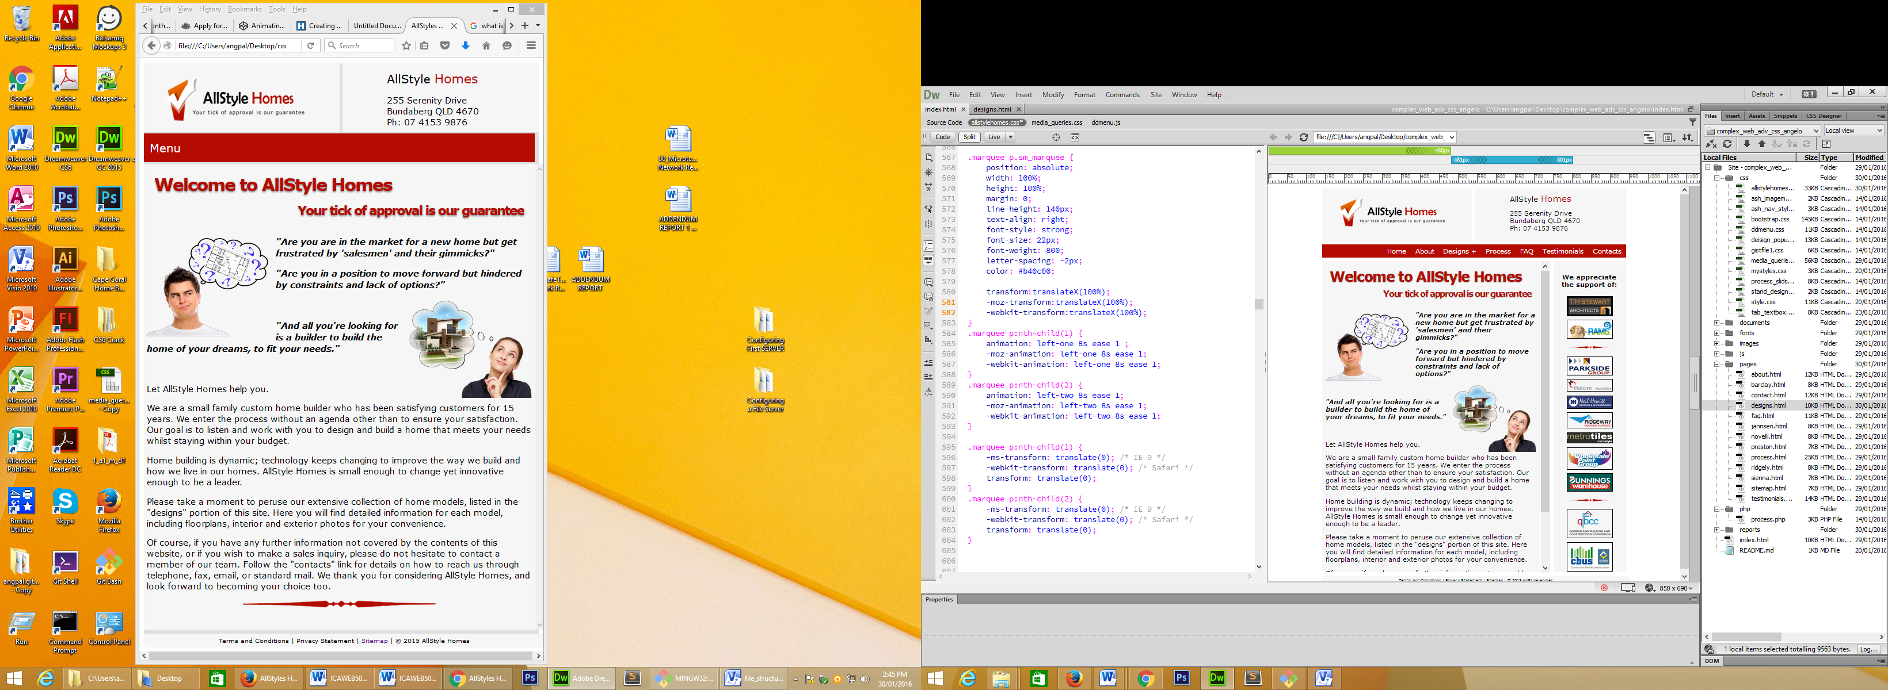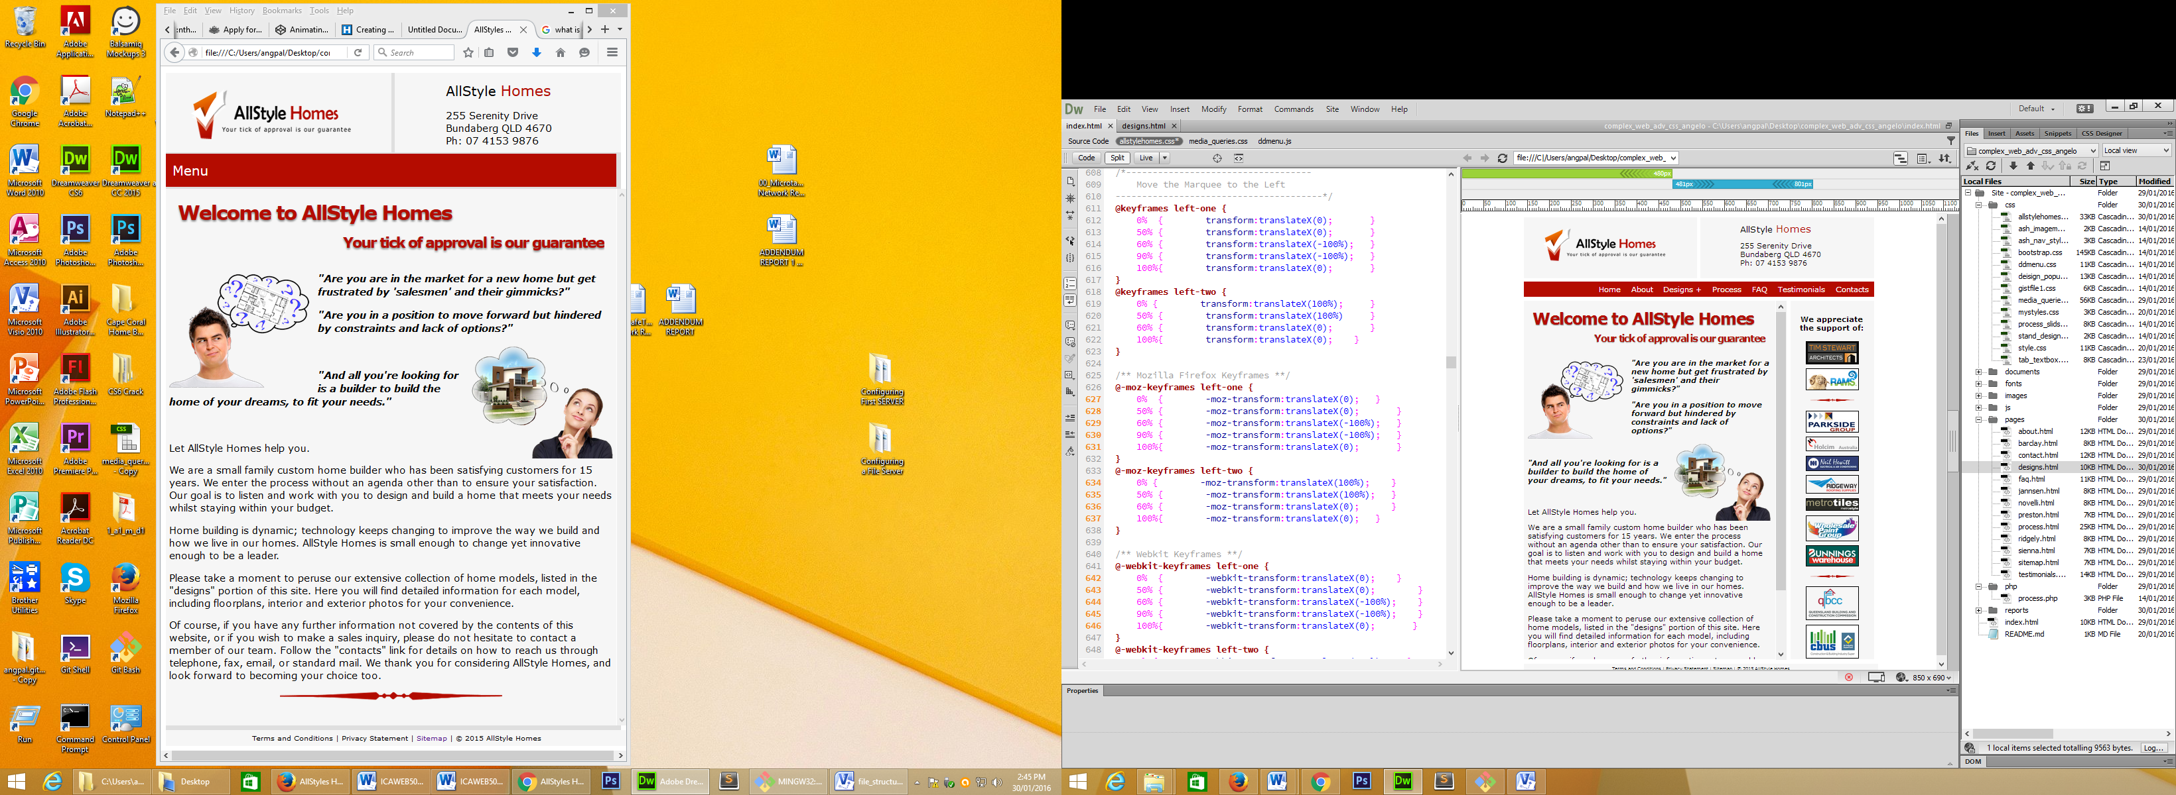

Figure : Example 2.The title marque – Text moves across the screen

Example 3 (below): Instead of the sliding marquee, the contact page has a large image at the top of the page. While this is not an example of animation, it is an example of a transformation, more precisely a “skew transformation on both the x-axis and y-axis. The code is quite simple “transform: skew(11deg, 5deg);”. The image is rotated (or skewed) 11 degrees on the x-axis and 15 degrees on the y-axis

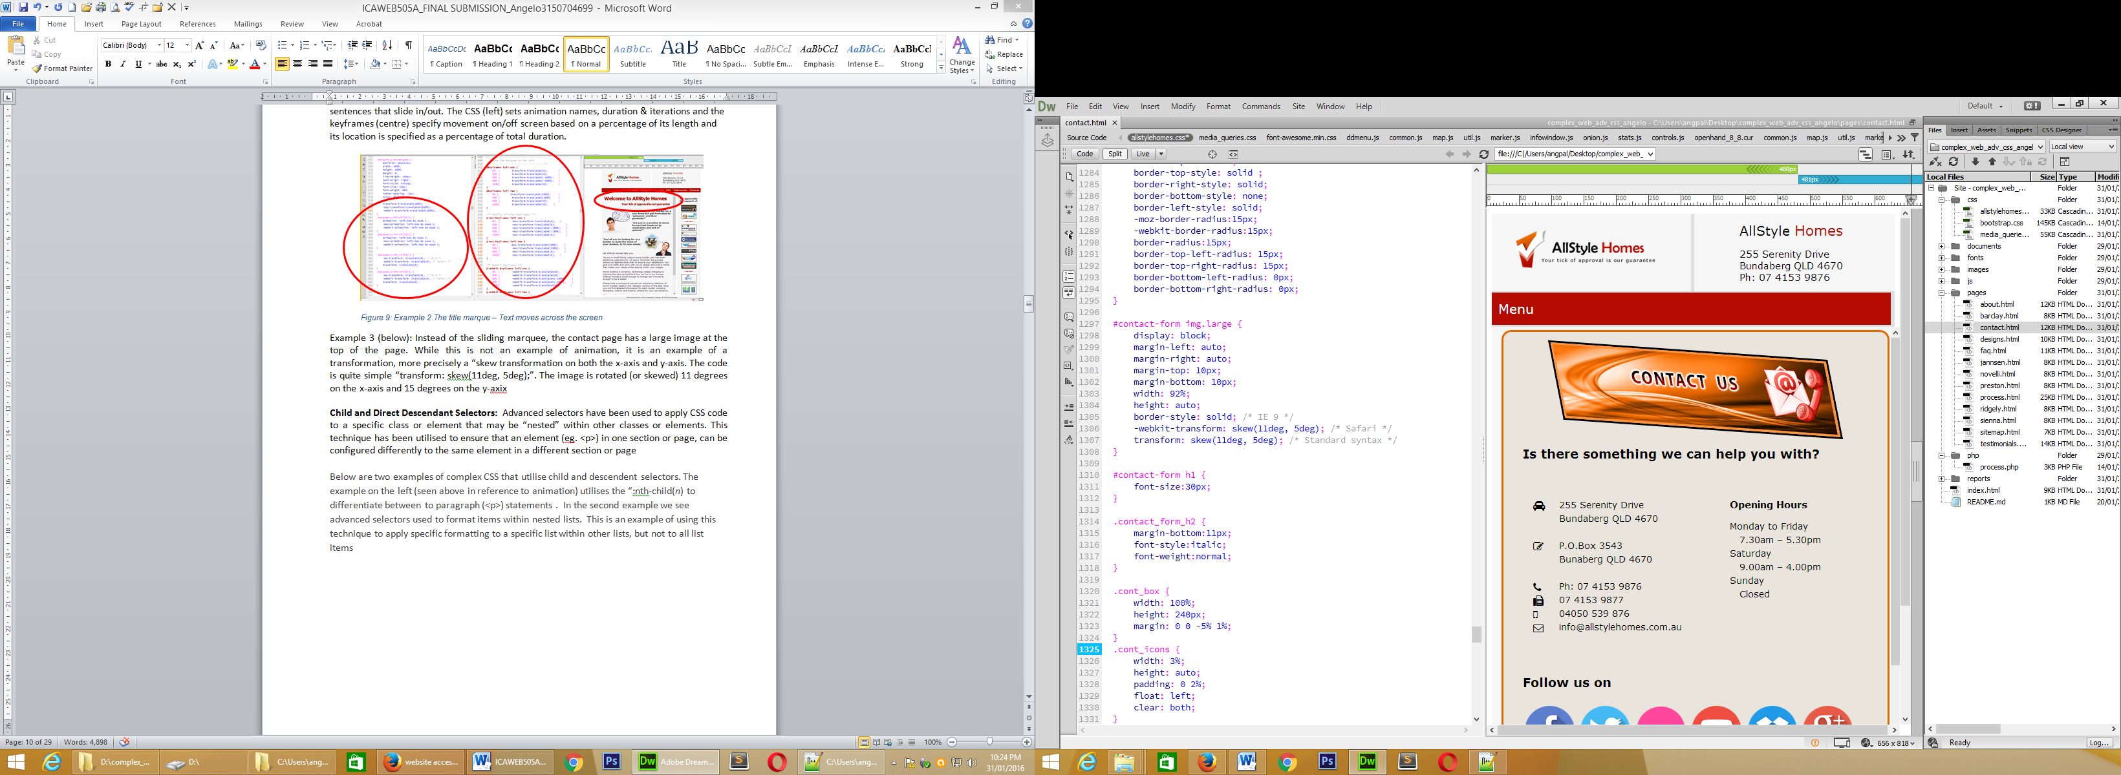

Figure : A skewed transformation on the x-axis and y-axis.

**Child and Direct Descendant Selectors:** Advanced selectors have been used to apply CSS code to a specific class or element that may be “nested” within other classes or elements. This technique has been utilised to ensure that an element (eg. <p>) in one section or page, can be configured differently to the same element in a different section or page

Below are two examples of complex CSS that utilise child and descendent selectors. The example on the left (seen above in reference to animation) utilises the “:nth-child(*n*) to differentiate between to paragraph (<p>) statements . In the second example we see advanced selectors used to format items within nested lists. This is an example of using this technique to apply specific formatting to a specific list within other lists, but not to all list items

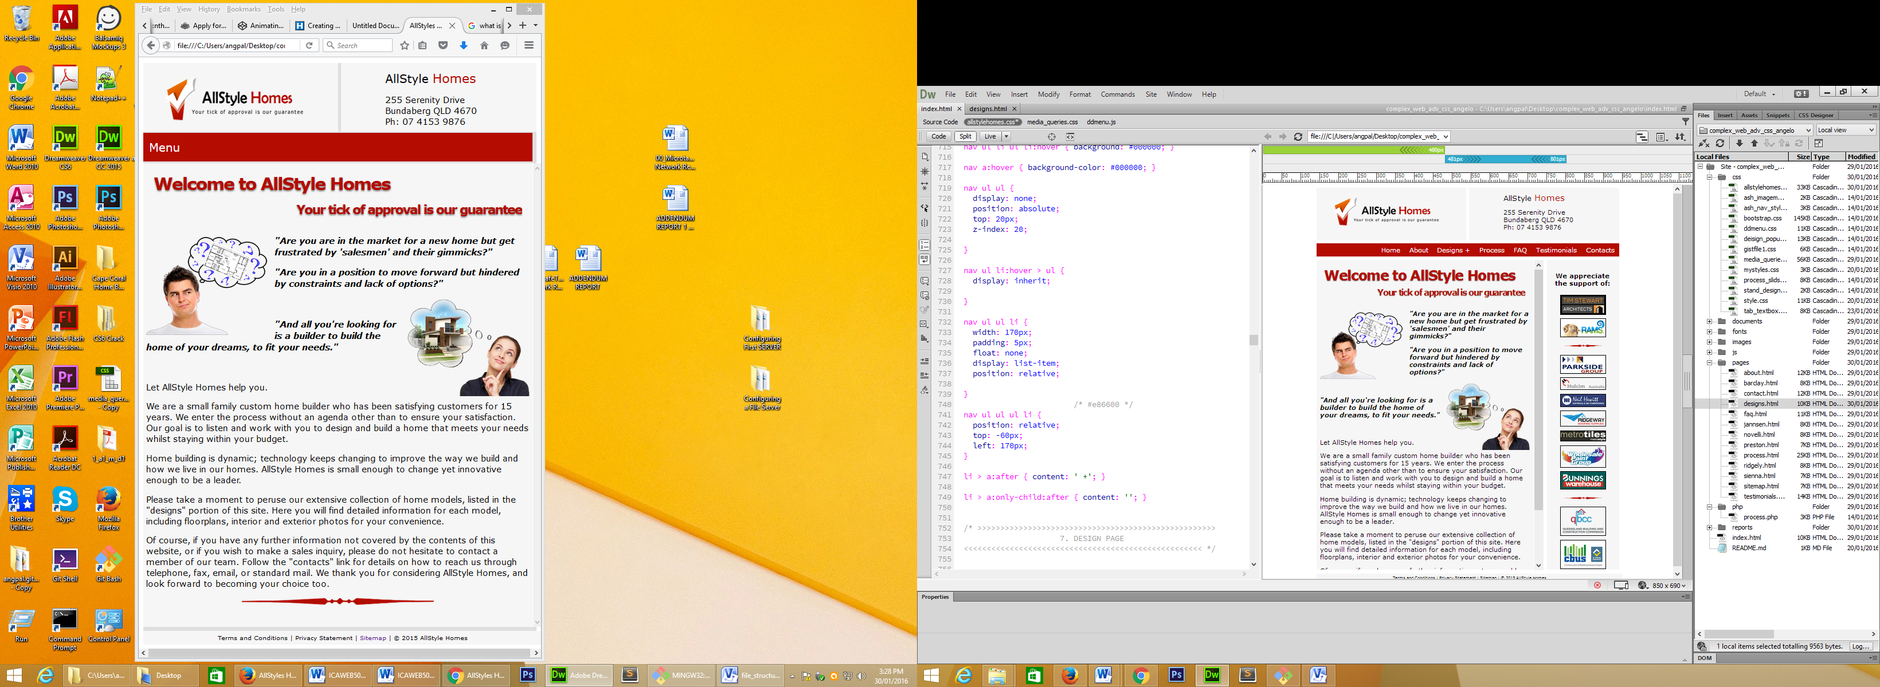

Figure : Two examples of child and descendent selectors.- (left) "nth-child(n)" and (right) nested lists.

**Transparency:** The advanced CSS code, transparency has been used in this website to create the visual effect of reducing the visibility of an element (and allowing the background of the parent element to be seen). This technique is an effective tool in drawing the user’s attention away from one element in favour of another, or to reduce its visual impact.

An example of this is seen in the example below, taken from the design.html page. In this example, when the cursor hovers over the thumbnail image, its opacity is reduced to 40% (or 0.4).

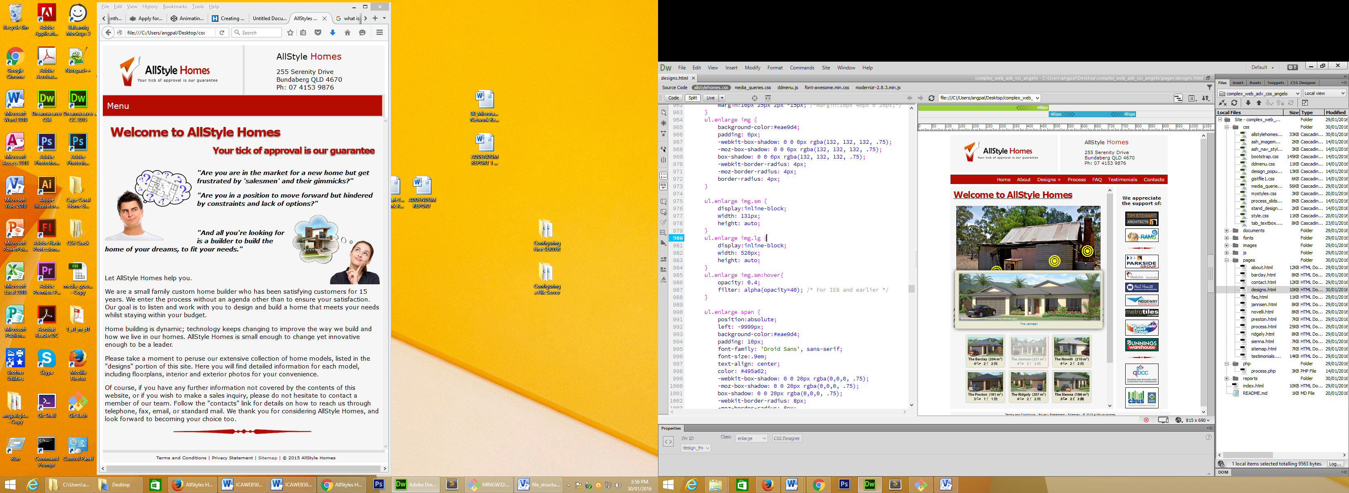

Figure : Above: Example of transparency applied in association with hovering.

**Element Sizing for Fluid Design:**  As stated earlier, media queries have been used to enable the website to be view on different devices of differing resolution. But they alone cannot achieve this. Throughout the CSS, quantitative data (such as widths and margins) have been written in percentages (%) as opposed to pixels and pt. Unlike the latter which are fixed quantities, percentages allow the element to take on a “fluid” quality, allowing it to take up a part of the available space. Another aspect of fluidity is the manner in which elemental sections can move and slot into space using properties such as float and clear, and elements such as “display:inline-block”

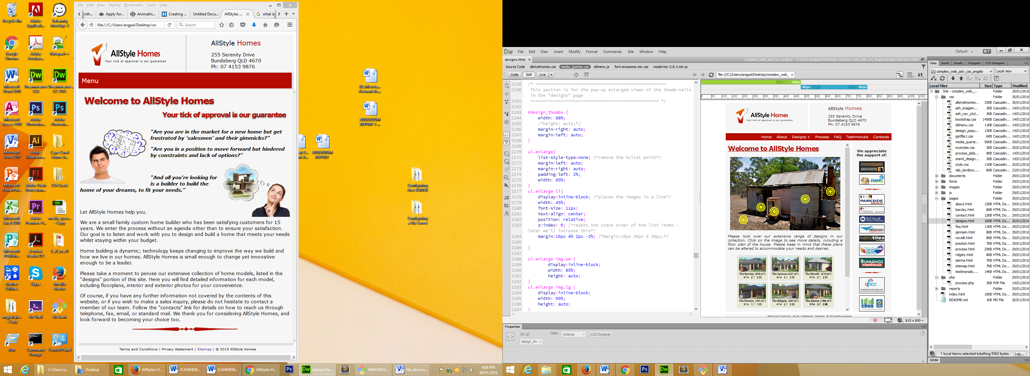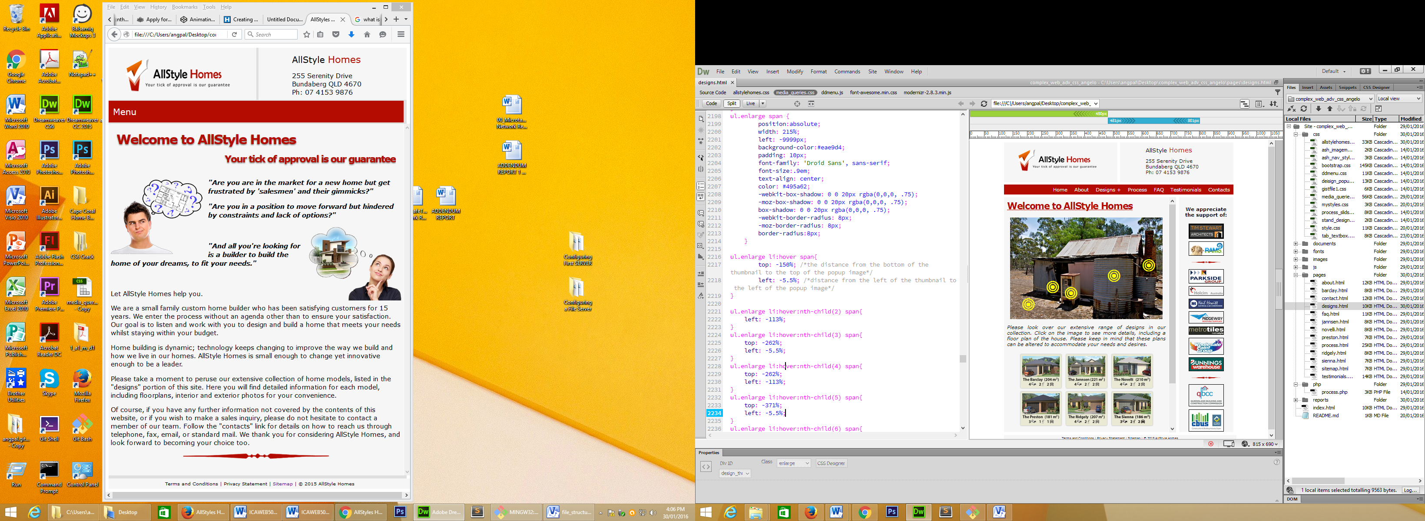

Figure : Several instance of using percentages to enable the element on the screen to resize automatically.

**Z-Index Layering:** When two or more elements need to occupy the same space, it is necessary to layer these item (one on top of the other. Z-Indexing is a CSS property that enables the developer to determine and specify the order in which items are placed in the order.

In the example below, the menu utilises a checkbox system. Click the checkbox (in this case the button called “Menu” and the rest of the menu drops down. A z-index of 200 is placed on this list item top ensure that it is placed higher in the layer stack than other list items, thus ensuring it is seen and the user can access the drop-down menu items.

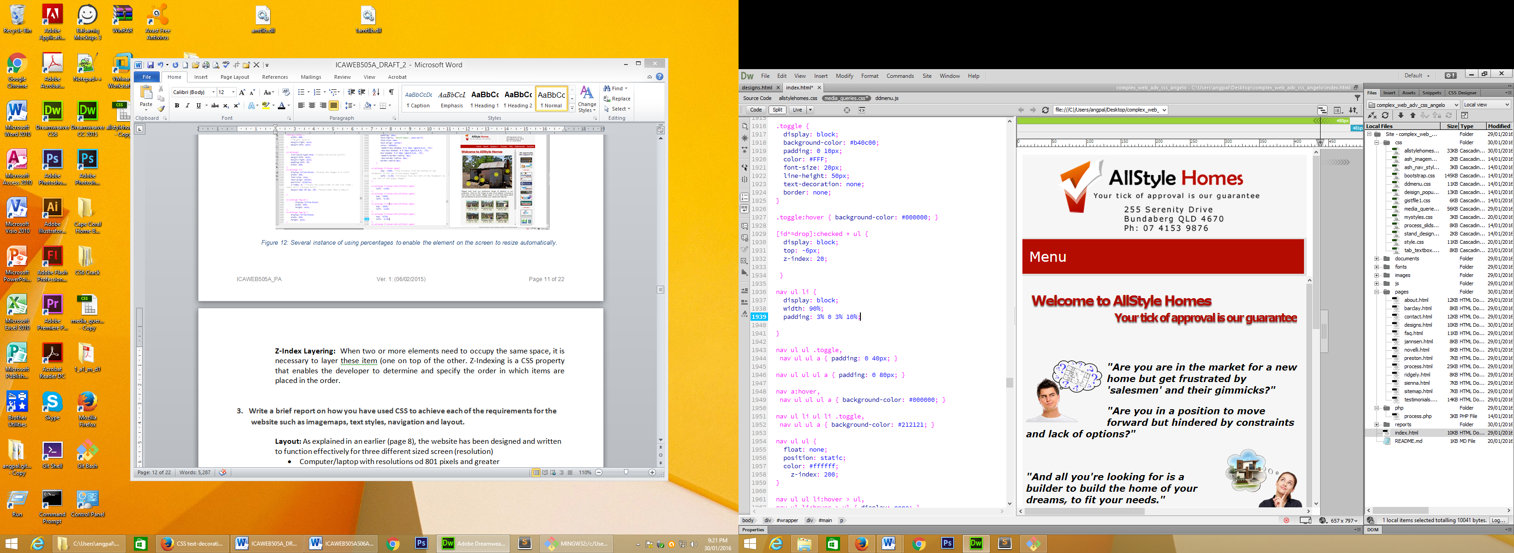

Figure : Above, the z-index property is applied to the drop-down-menu.

In the following example, found on the design page, when the user hovers their cursor over the icon, a box of text moves onto the screen and positions itself above the icon. To ensure that this text is above the image, a z-index of 5 has been attached to the CSS.

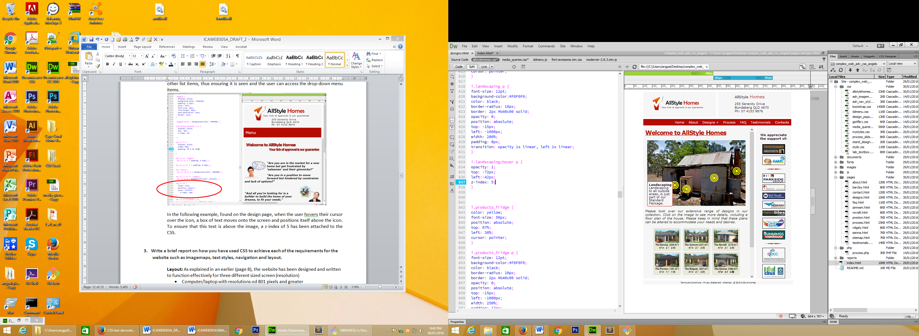

Figure : Above - The z-idex is applied to a textbox.

**3. Write a brief report on how you have used CSS to achieve each of the requirements for the website such as imagemaps, text styles, navigation and layout.**

**Layout:** As explained in an earlier (page 8), the website has been designed and written to function effectively for three different sized screen (resolution)

* Computer/laptop with resolutions od 801 pixels and greater
* Tablets with resolutions between 481 pixels and 801pixels
* Smartphones with resolutions below 481 pixels

This has been achieved with the application of media queries and “fluid” CSS code

The layout is the same for all pages and follows the sketch depicted in the wireframe diagrams on page 4. This being said, the layout changes between media queries.

In the transition from desktop to tablet, the sidebar is removed. In addition, in the transition from tablet to smartphone, the right-header is removed. This has been achieved simply adding the property “display: none”.

In the specific case of the left header (on the home page it has and animation, but on all the other page it is a static image), two different “leftHeader” DIVs had to be written with two different CSS. Again the property “display: none” was used to have the appropriately CSS open on the appropriate page.

**Text Styles:** The use of classes, enabled the basic <p> element to be configured with a multitude of different properties – different fonts (font-family), sizes (font-size), colours (color), darkness (font-weight), alignments (text-align), styles (font-style), decorations (text-decoration), etc – and combination.

The Design Brief and Style Guide was very specific in relation to many design elements, including text. Every effort was made to adhere to these specifications. “Creative Liscence” was enacted in other textual features. On the page presenting client testimonial, comments text-style set to italic to convey a verbal or auditory sense.

On the homepage, we wanted the three opening questions stand-out and convey emotion, so we uses CSS to set font-size to 17pixels, weight to 800 and style to italic. The marque/heading on the homepage had a slight text-shadow applied to give it a 3D effect and thus stand out on the page.

**ImageMap:** The effectiveness of the imagemap was the incorporation of scalable vector icons found online and linked to the webpage “<link href="../css/media_queries.css" rel="stylesheet" type="text/css">”

Through CSS we were able to set the main image on the page with a position of “relative” to the page (thus making it responsive. Positioned above the image were the individual icons. These were positioned “absolute” (thus making them fixed in relation to the image, but still appearing fluid and responsive) and positioned with fixed coordinates (initially with fixed pixels but then with percentages in the media-queries. In addition to this, a small portion of text (<p>) was animated to slide onto the screen when the cursor hovered above the icon using the code ”transition: opacity 1s linear, left 1s linear;”. This line of code made the “block” of text move from the left (off screen to the right) into position above the icon within 1 second. During this same time it also transitioned from invisible to visible

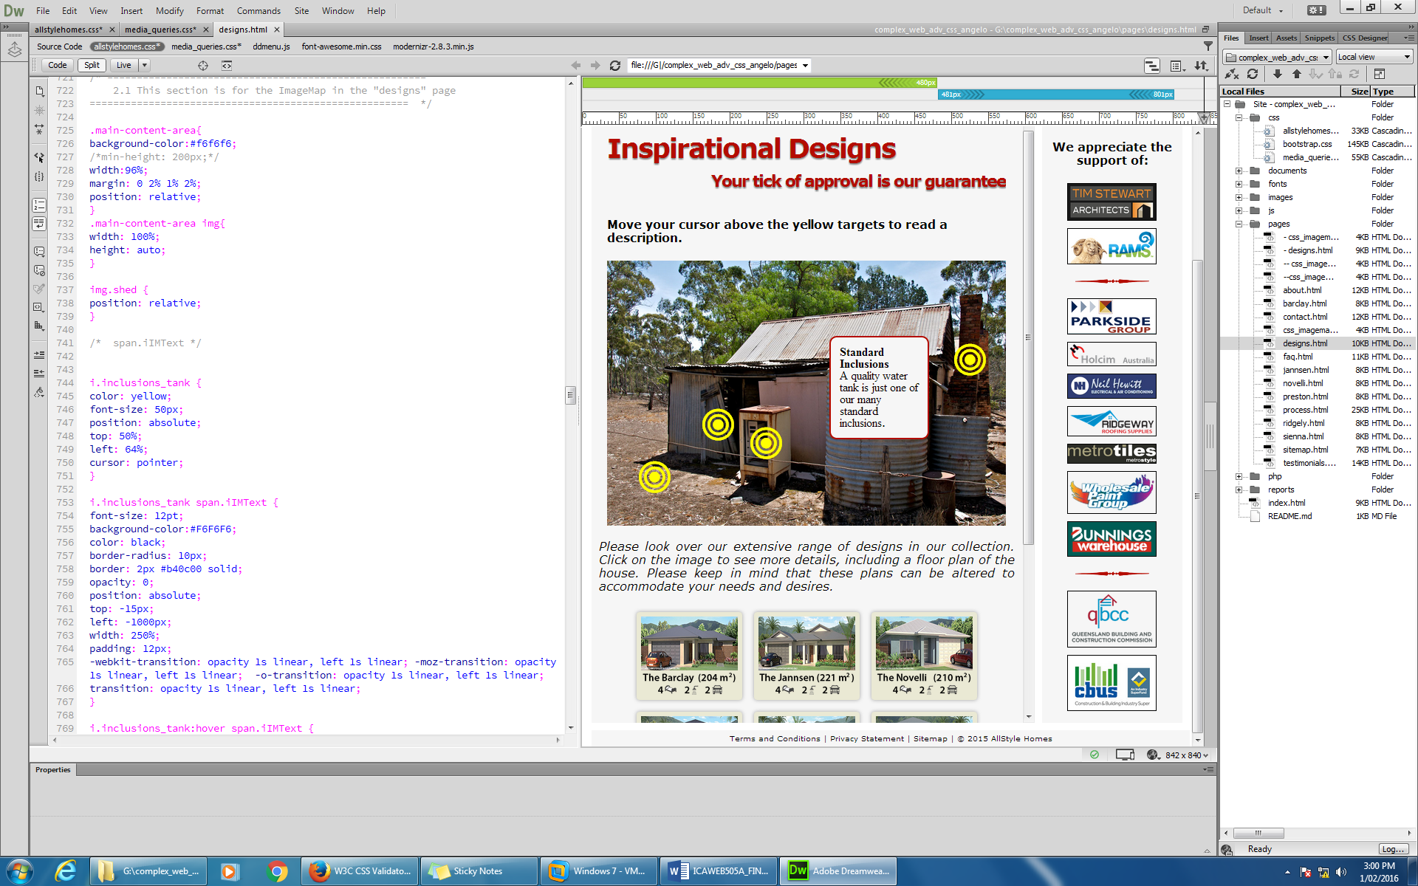

**Navigation:** The Navigation Bar was one feature we identified early in the design phase, as needing to be interactive and responsive to different display device resolutions. We also identified early on, that this was more difficult than just adding percentages.

The solution chosen, was similar to that applied to the spinning logo on the homepage. In essence we were creating two separate menus; one for the large desktp and one for hand-held devices. When a user was in one viewing mode the other mode would be hidden from sight by a combination of CSS and media-queries.

Both menues would be structured around unordered lists. The menu for the desktop was to take the form of a horizontal bar, utilizing the element “display:inline-block”.

The menu for the hand-held device takes the form of a vertical drop-down list (concealed behind a single button,) and utilizes the element “display: block”. In the HTML code this is set-out as a checkbox toggle. Clicking the checkbox releases the drop-down menu elements (as opposed to hovering on it for desktop menus).

The drop-down-menu is comprised of a number of unordered lists within other unordered lists. This structure is reflected in the CSS structure, with several child and descendant selectors being used.

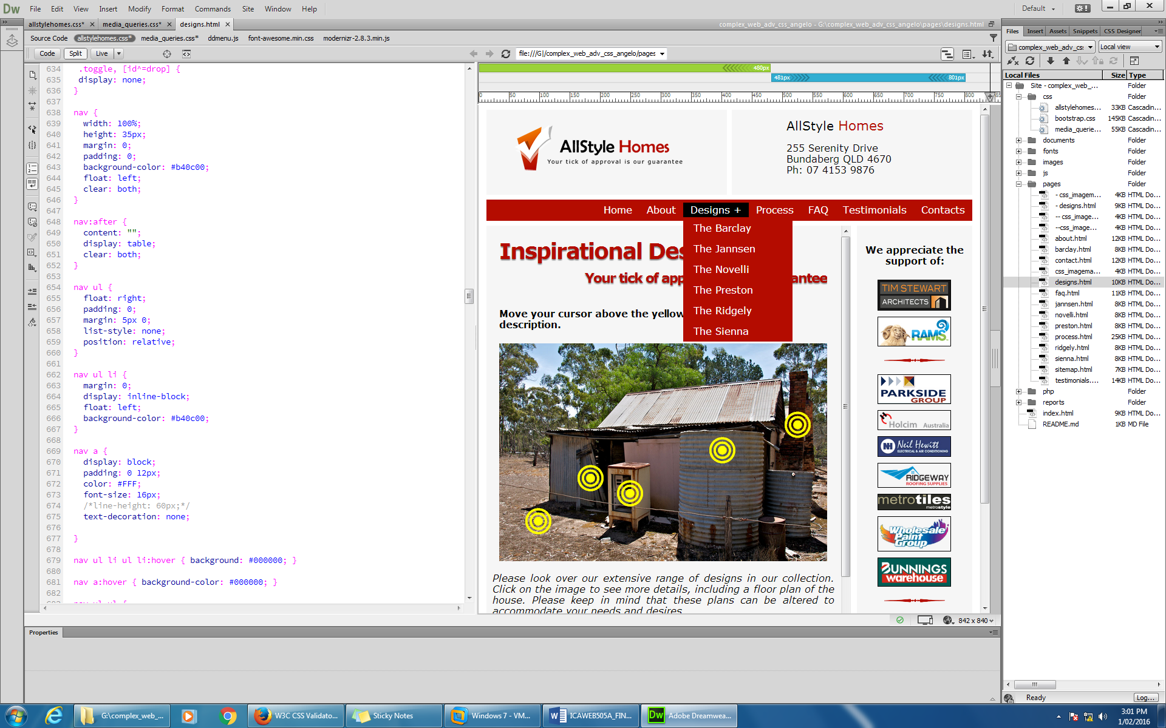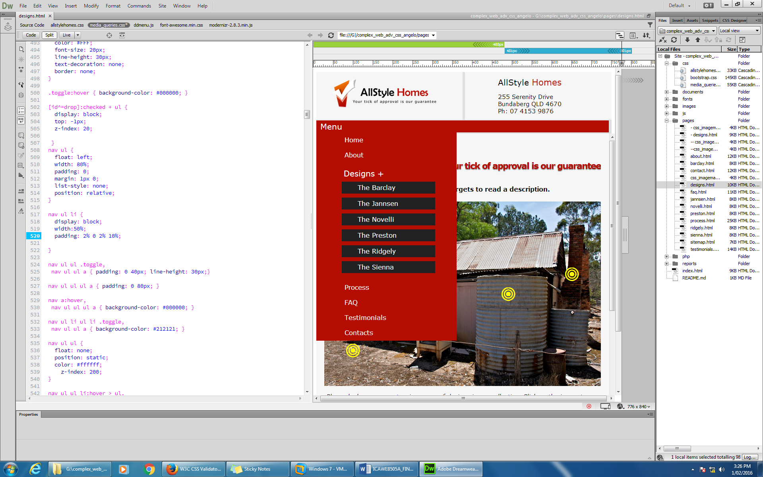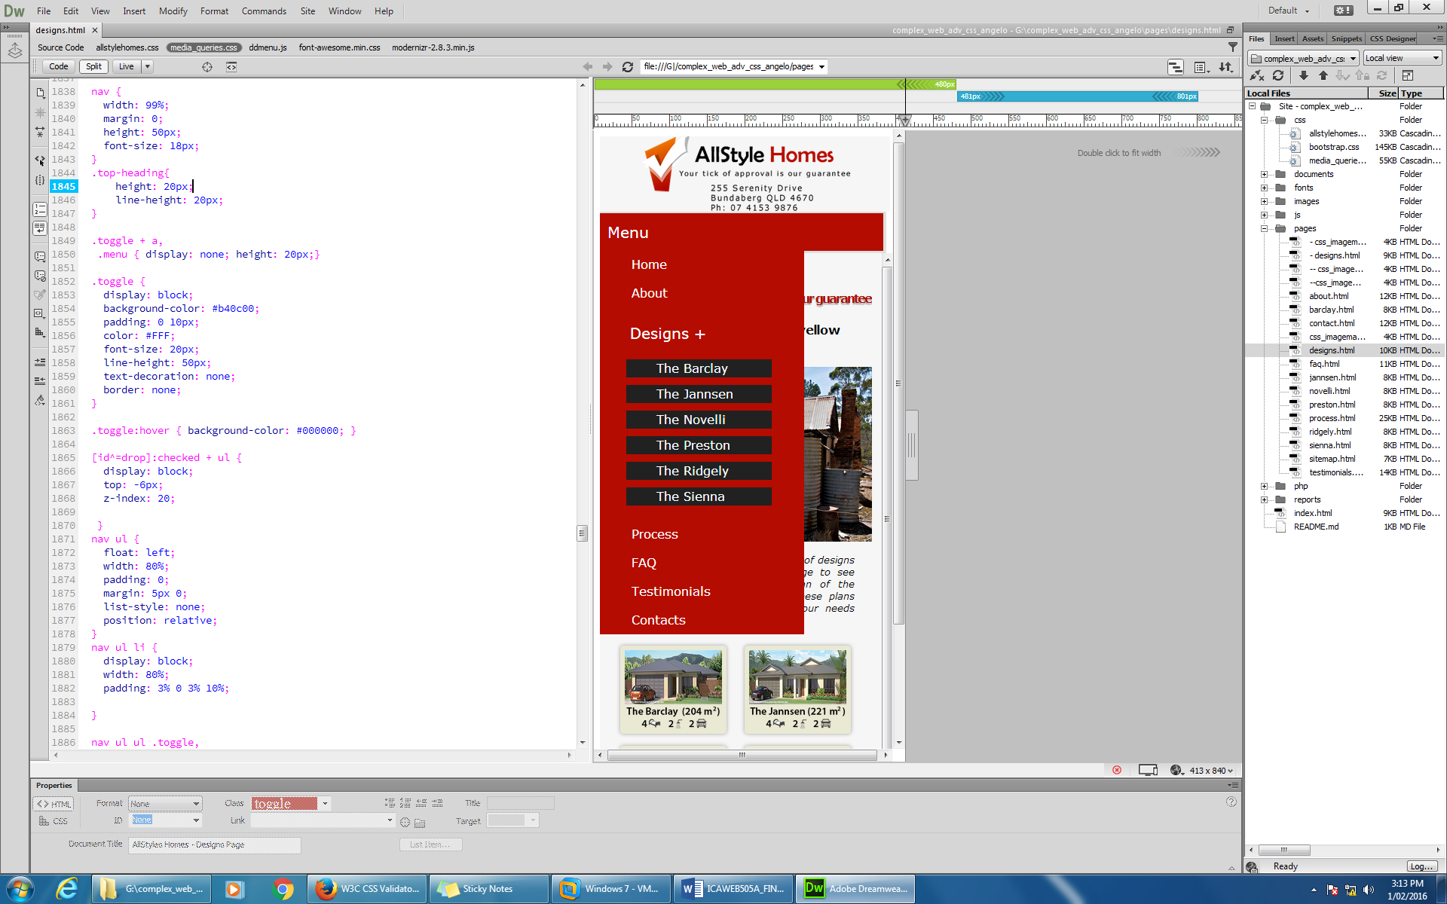

## Task 3 - test and validate the site

For this task you are required to test the website and rectify any inconsistencies or issues with the site. You should develop a checklist of all test criteria that you need to test against. You should:

1. Test the website across a number of different browsers to ensure consistency of presentation, (submit these as screen shots)

**Mozilla Firefox v.44**

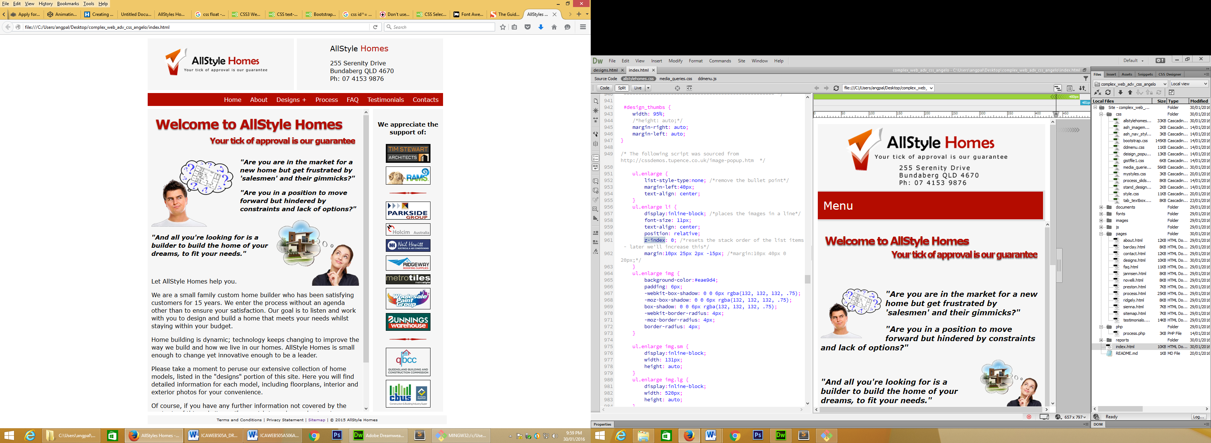

Figure : Above, website running on a Firefox, with a screen resolution of approx. 1080px.

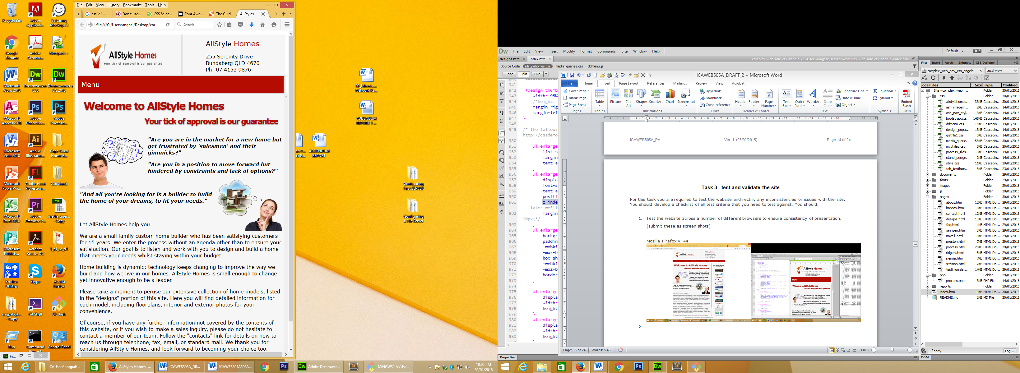 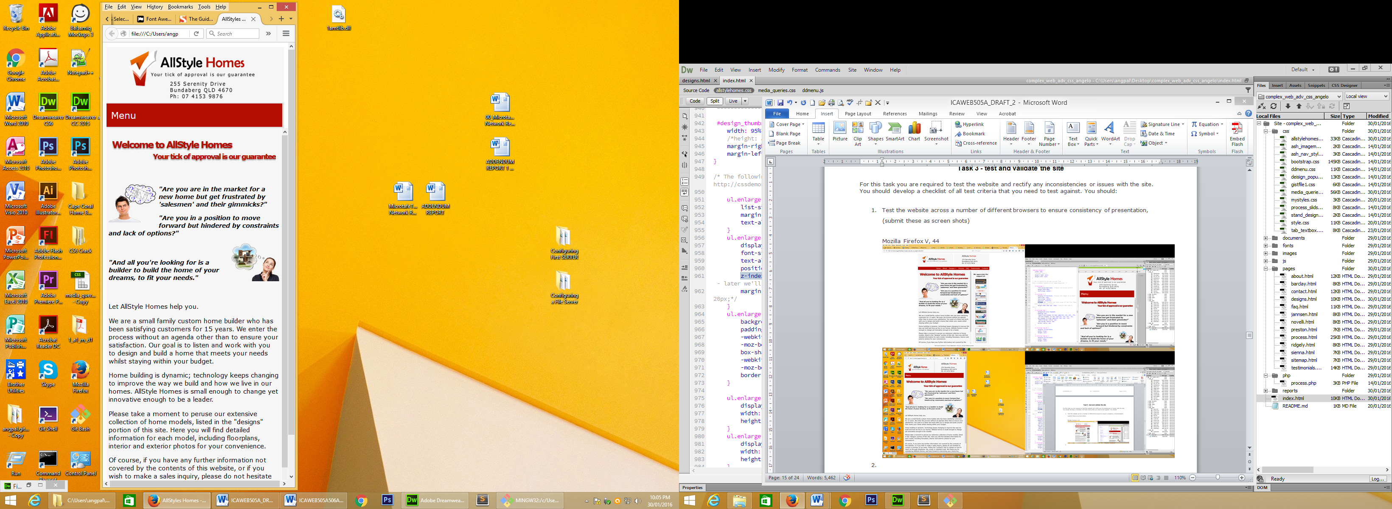

Figure : Above left: Firefox, with screen resolution of approx.720px. Above right: Firefox, with screen resolution of approx.380px.

**Windows Internet Explorer v.11**

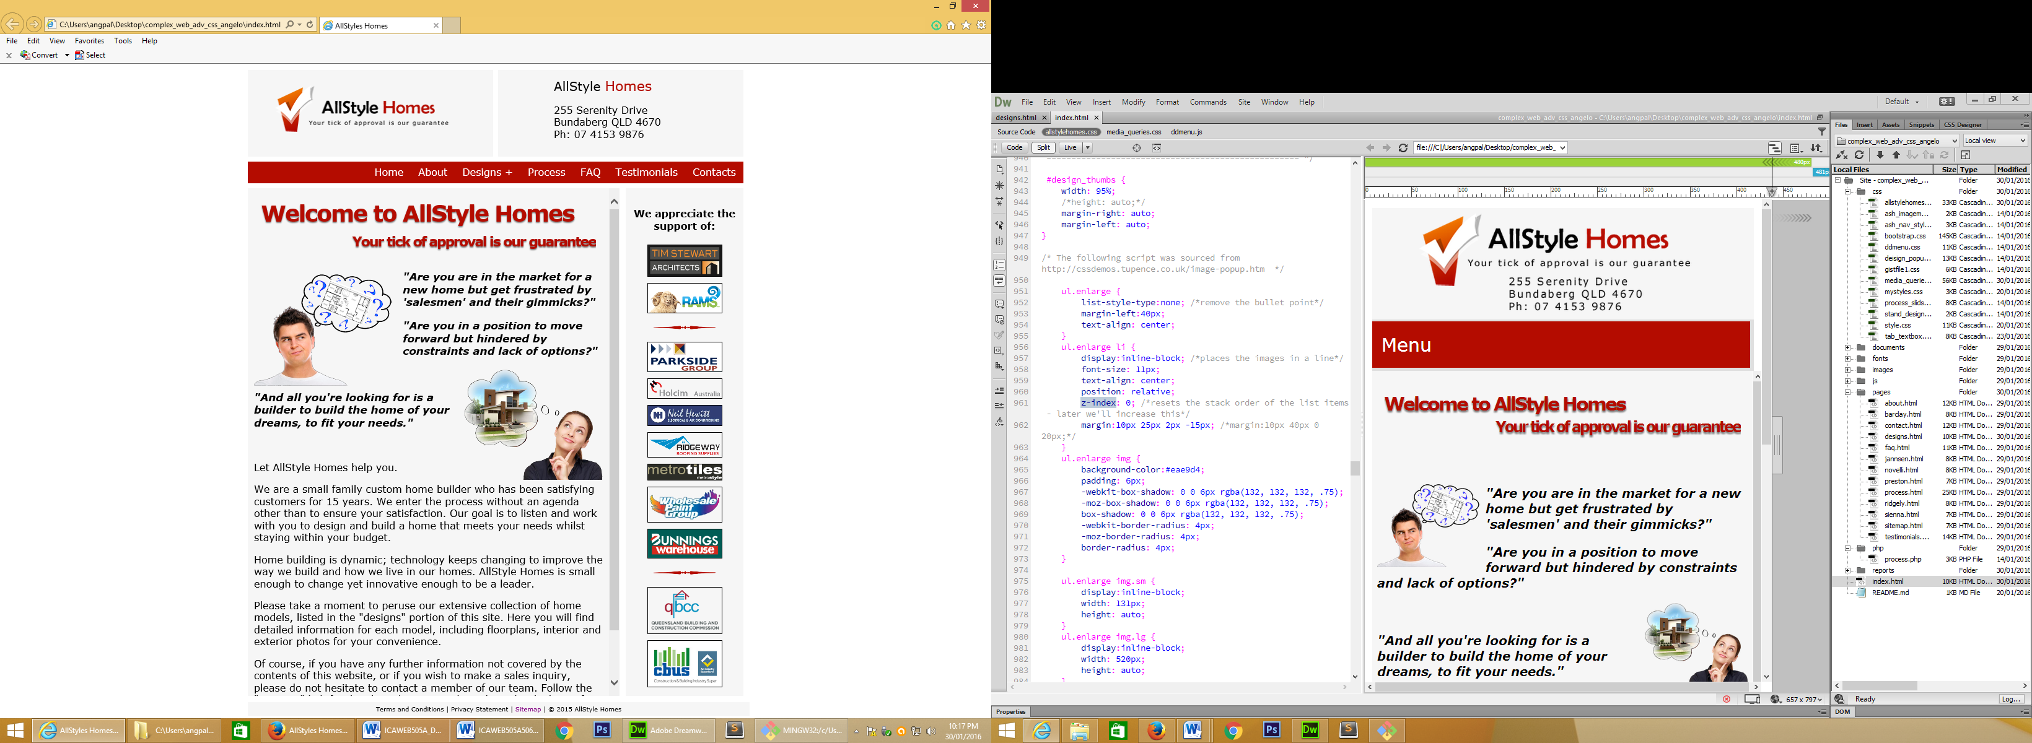

Figure : Above, website running on a Internet Explorer, with a screen resolution of approx. 1080px.

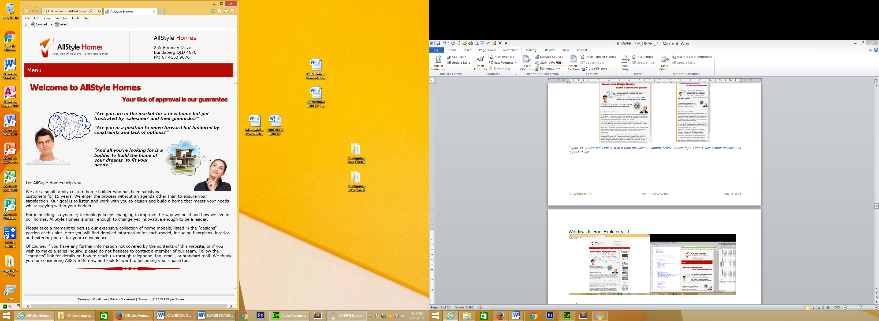 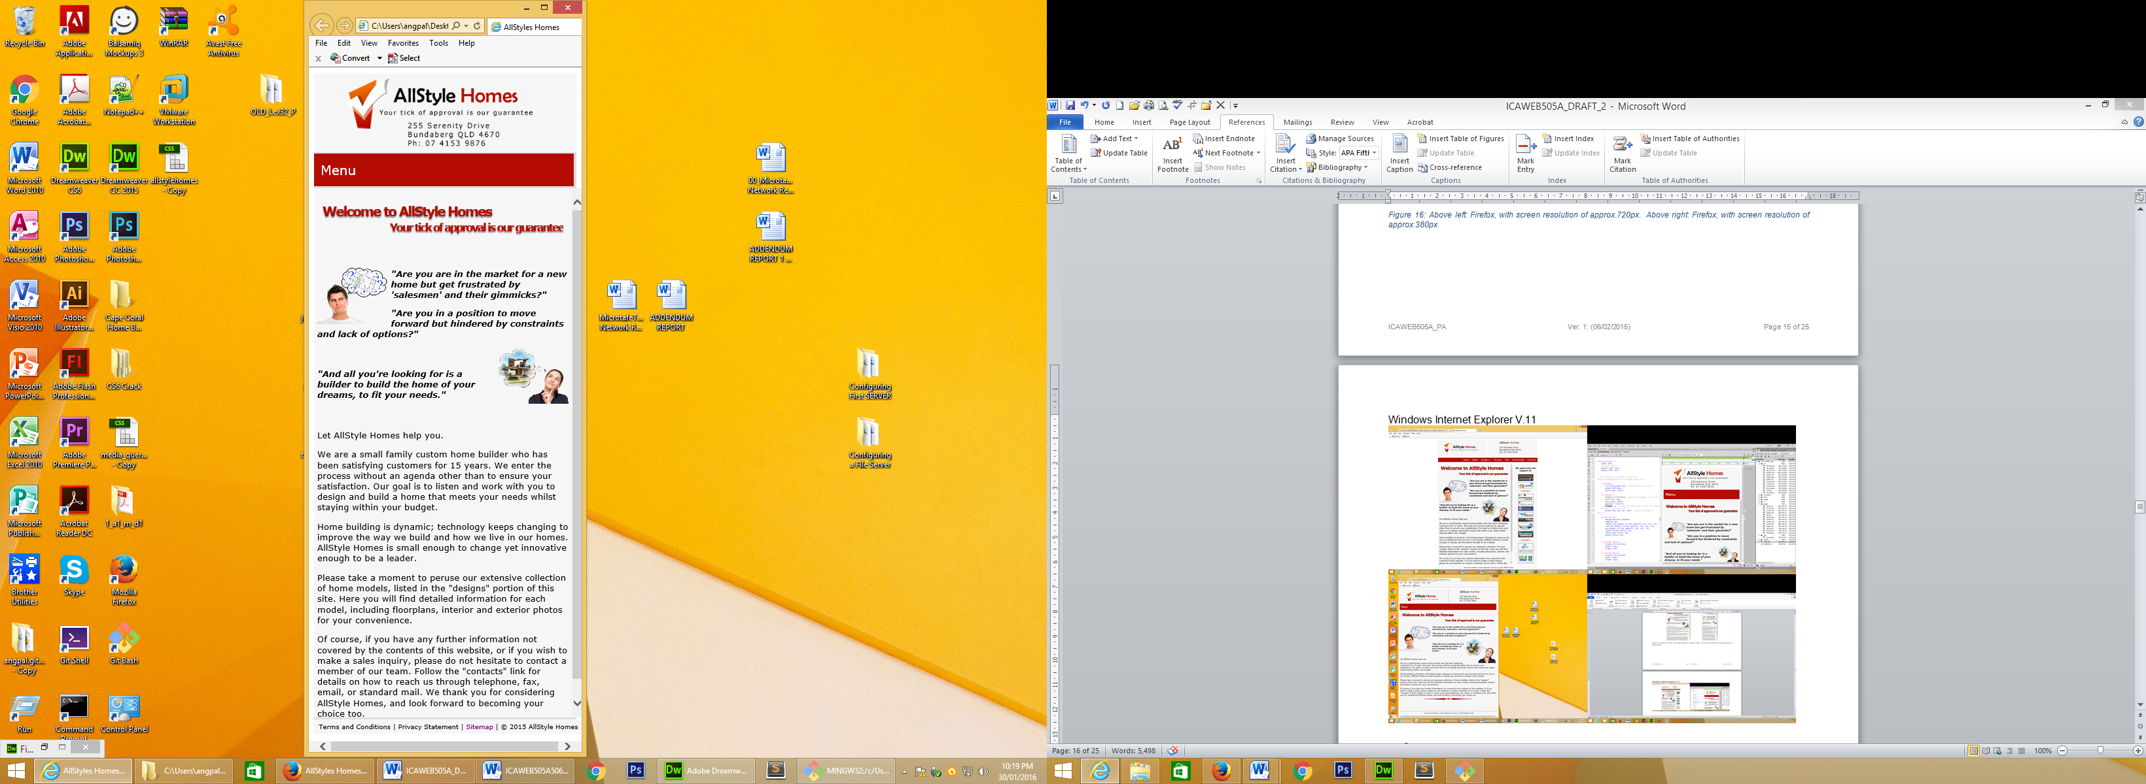

Figure : Above left: Internet Explorer, with screen resolution of approx.720px. Above right: Internet Explorer, with screen resolution of approx.380px.

**Opera v.34**

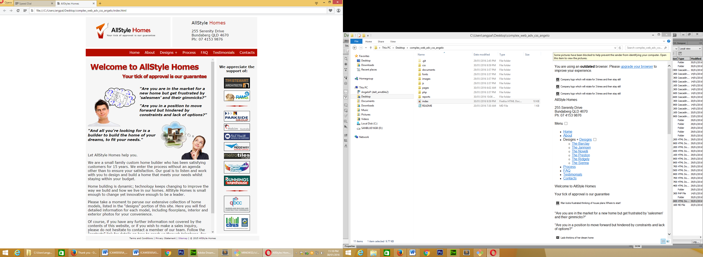

Figure :Above, website running on a Opera, with a screen resolution of approx. 1080px

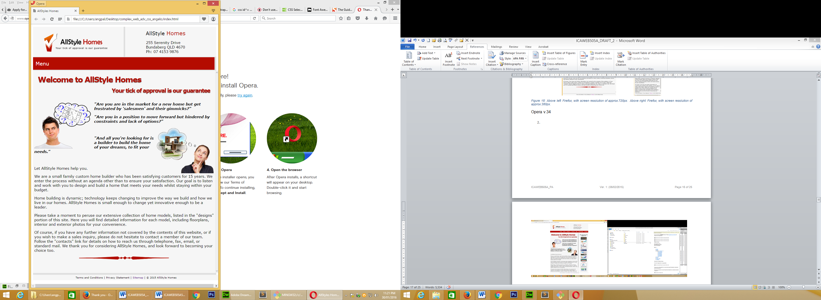 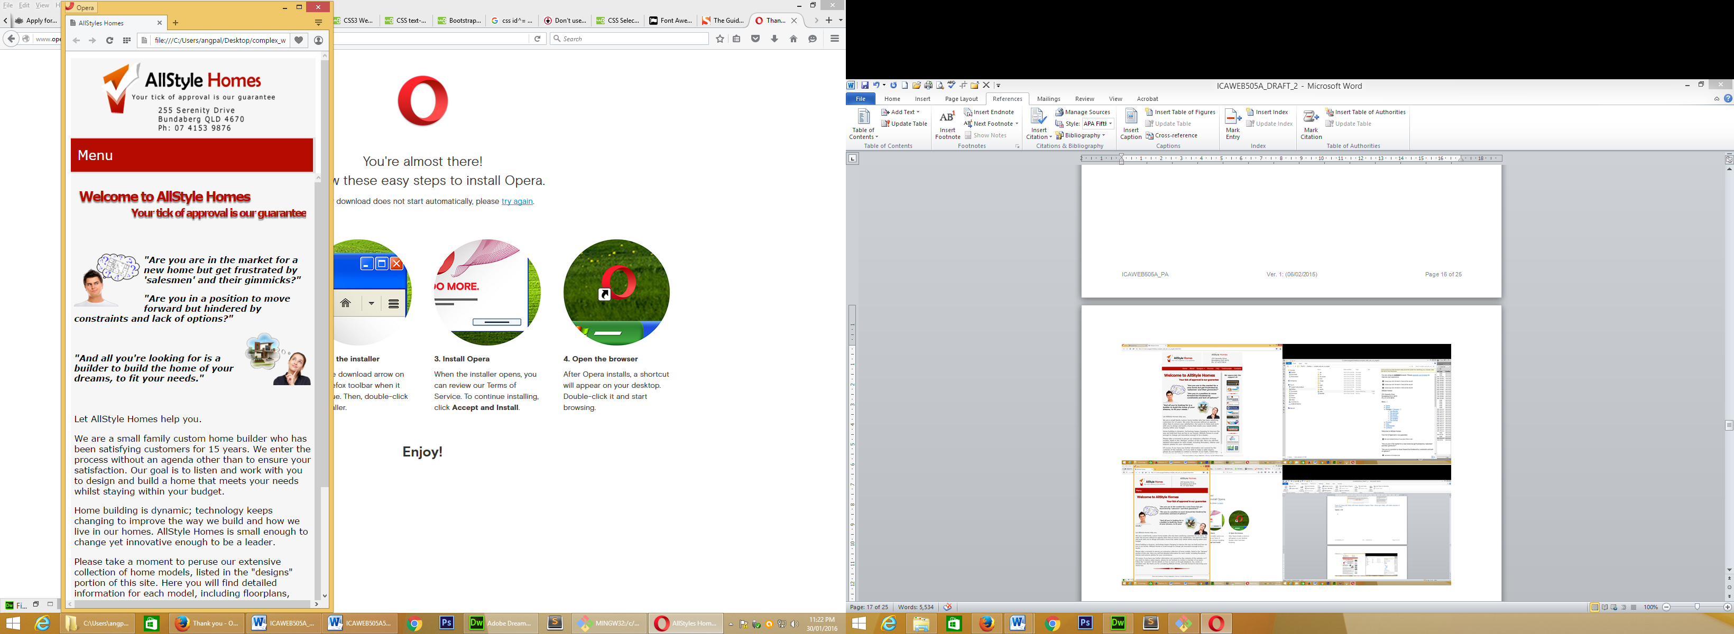

Figure : Above left: Opera, with screen resolution of approx.720px. Above right: Opera, with screen resolution of approx.380px.

1. ***Ensure the site meets each of the technical specification criteria***

[Seer page 6 for the response to this question

1. ***Ensure the site meets each of the style guide criteria***

Page 5 and 6 of this report outlines the requirements specified in the Style Guide section of the Design Brief. I am confident that the website has satisfied the requirements as outlined.

1. ***Validate your site, including your CSS against industry standards (W3C) and (submit these as screen shots)***

**index.html**

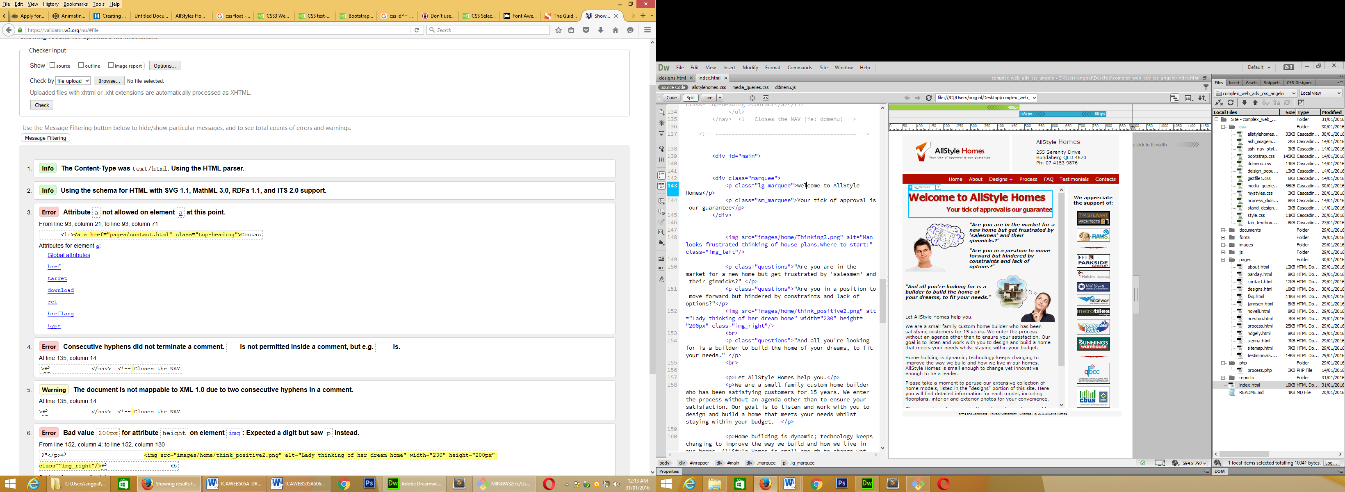

Solutions:

3 – Correction made by removing additional “a”

4 & 5 – Ignored. Warning refers to a comment, and as such has no bearing on functionality

6 – Correction made by removing “px”

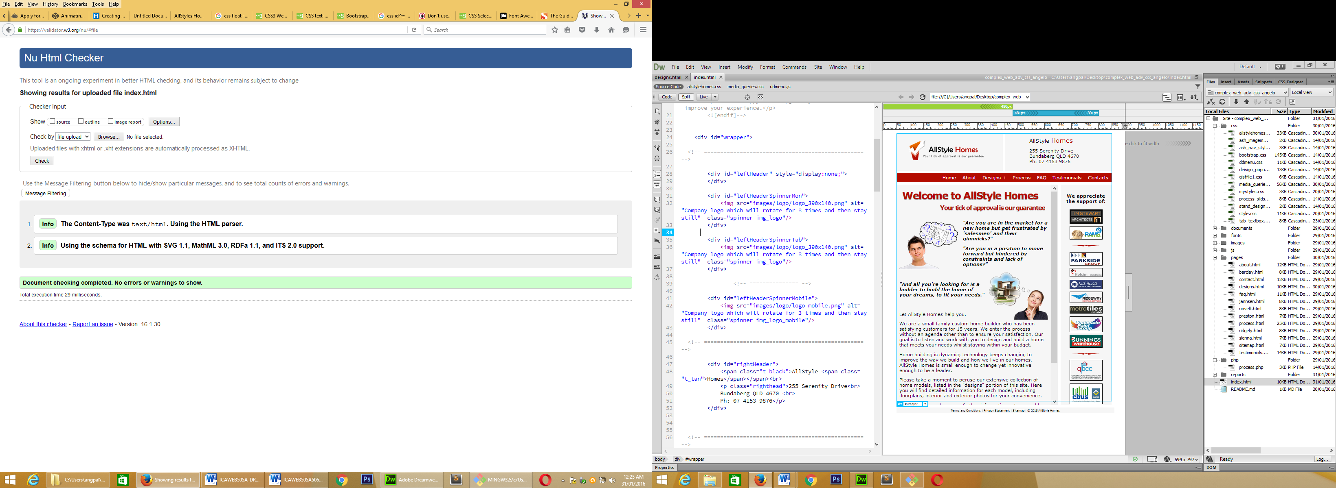

**about.html**

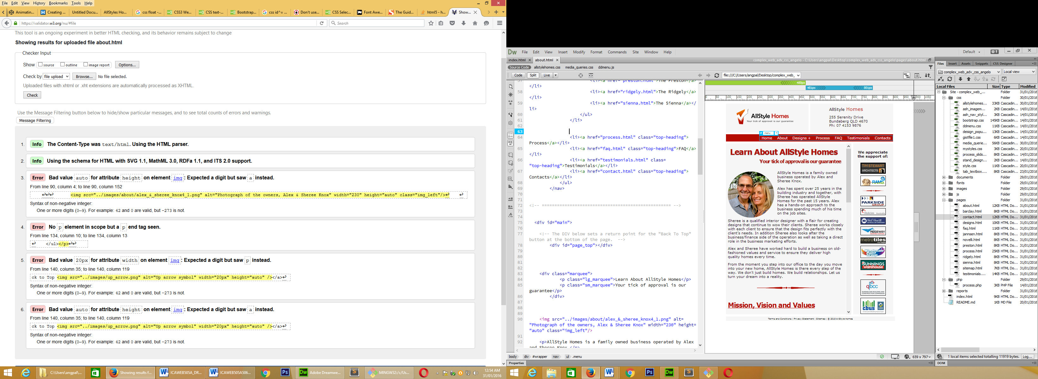

Solution:

3. Corrected “auto” replaced with a numerical figure

4. Validator claimed there was a missing start tag. The problem was in fact that there was an unordered list within the <p> element. Solution was to take the unordered list out of the <p> element.

5. Corrected by removing “px”

6. Corrected “auto” replaced with a numerical figure

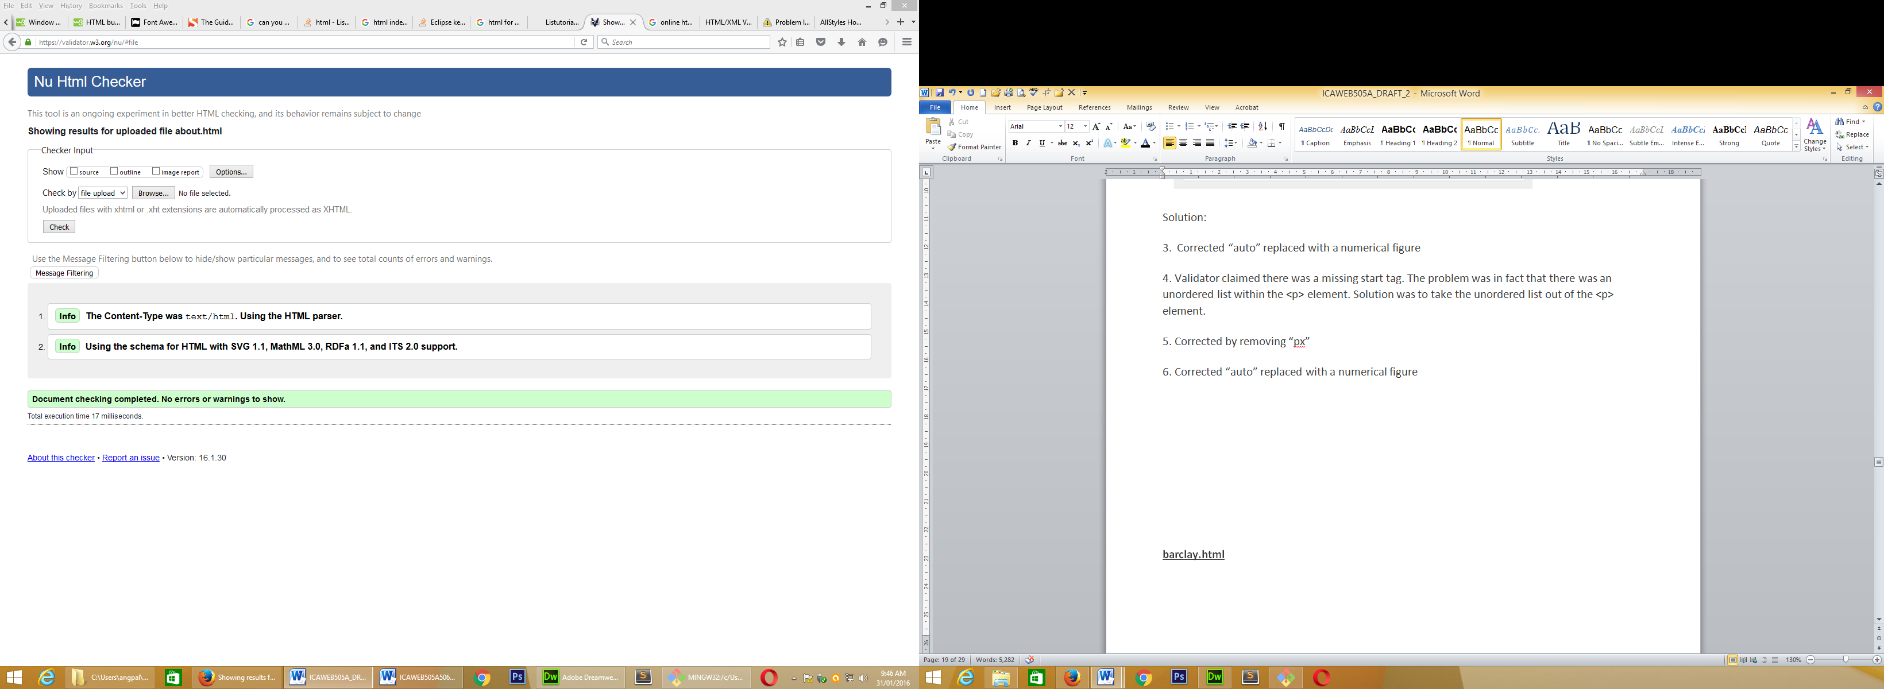

**barclay.html**

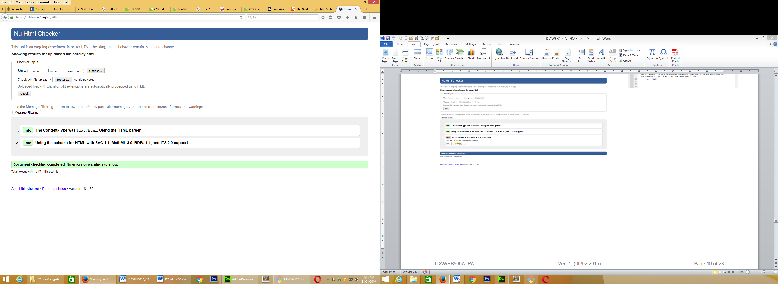

**contact.html**

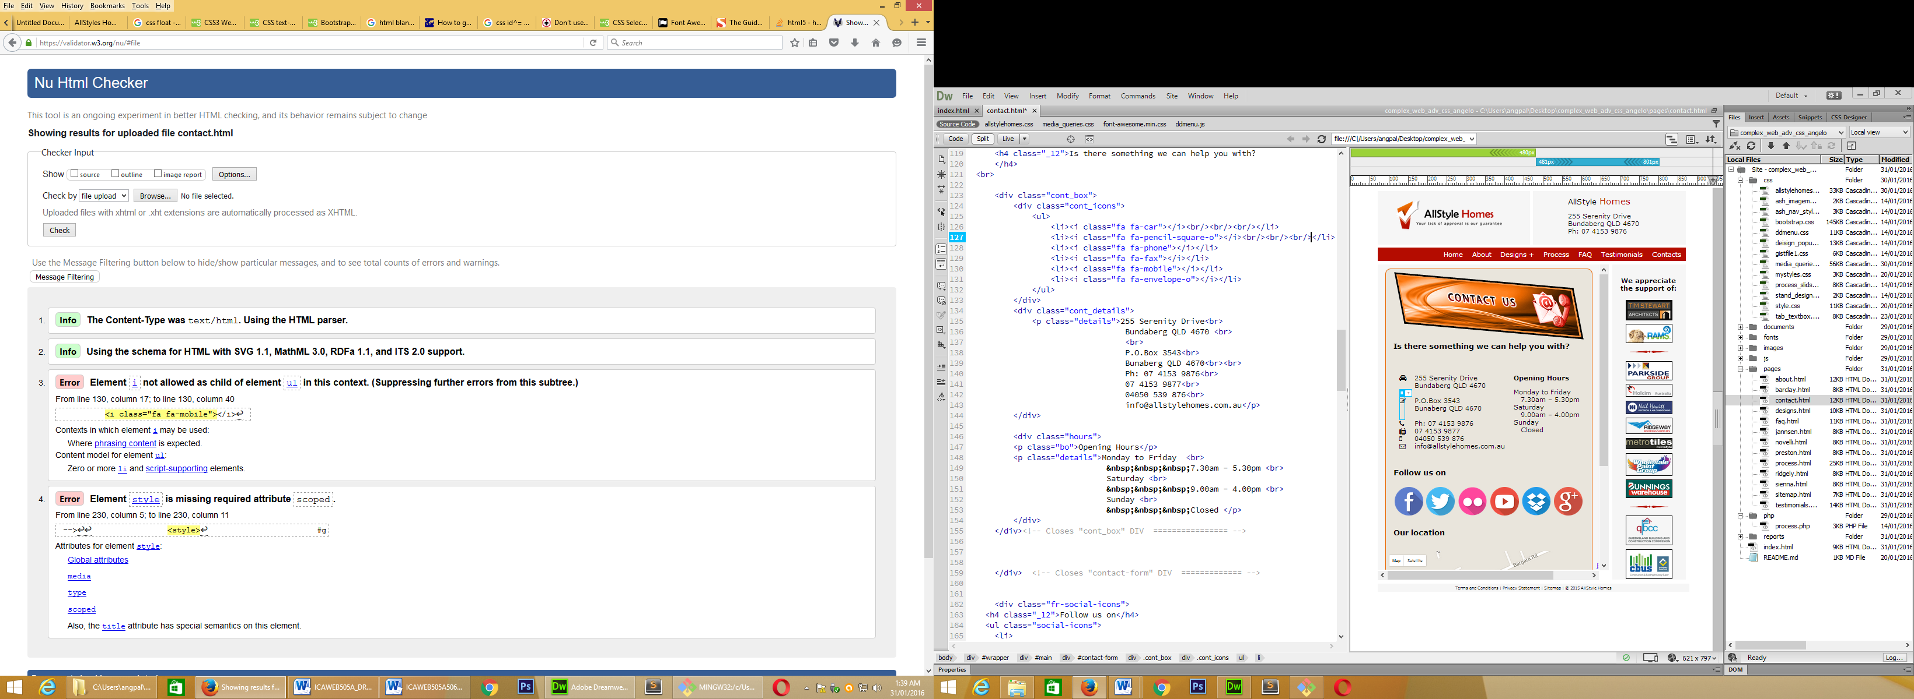

Solutions:

3. The “**<i class="fa fa-mobile">**</i>” needed to be enclosed in <li> </li>

4. The dive <style> had to be changed to <style scoped>

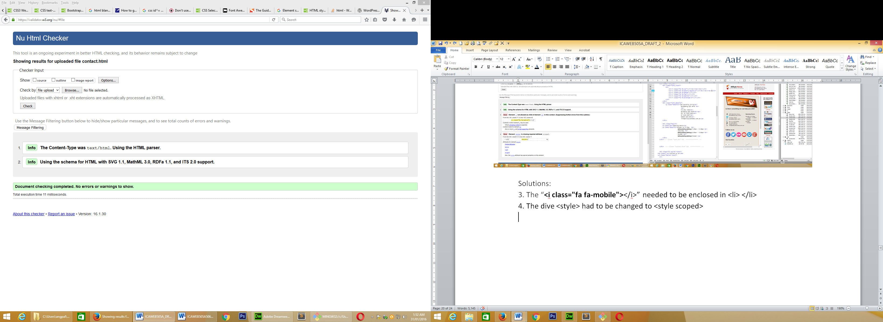

**designs.html**

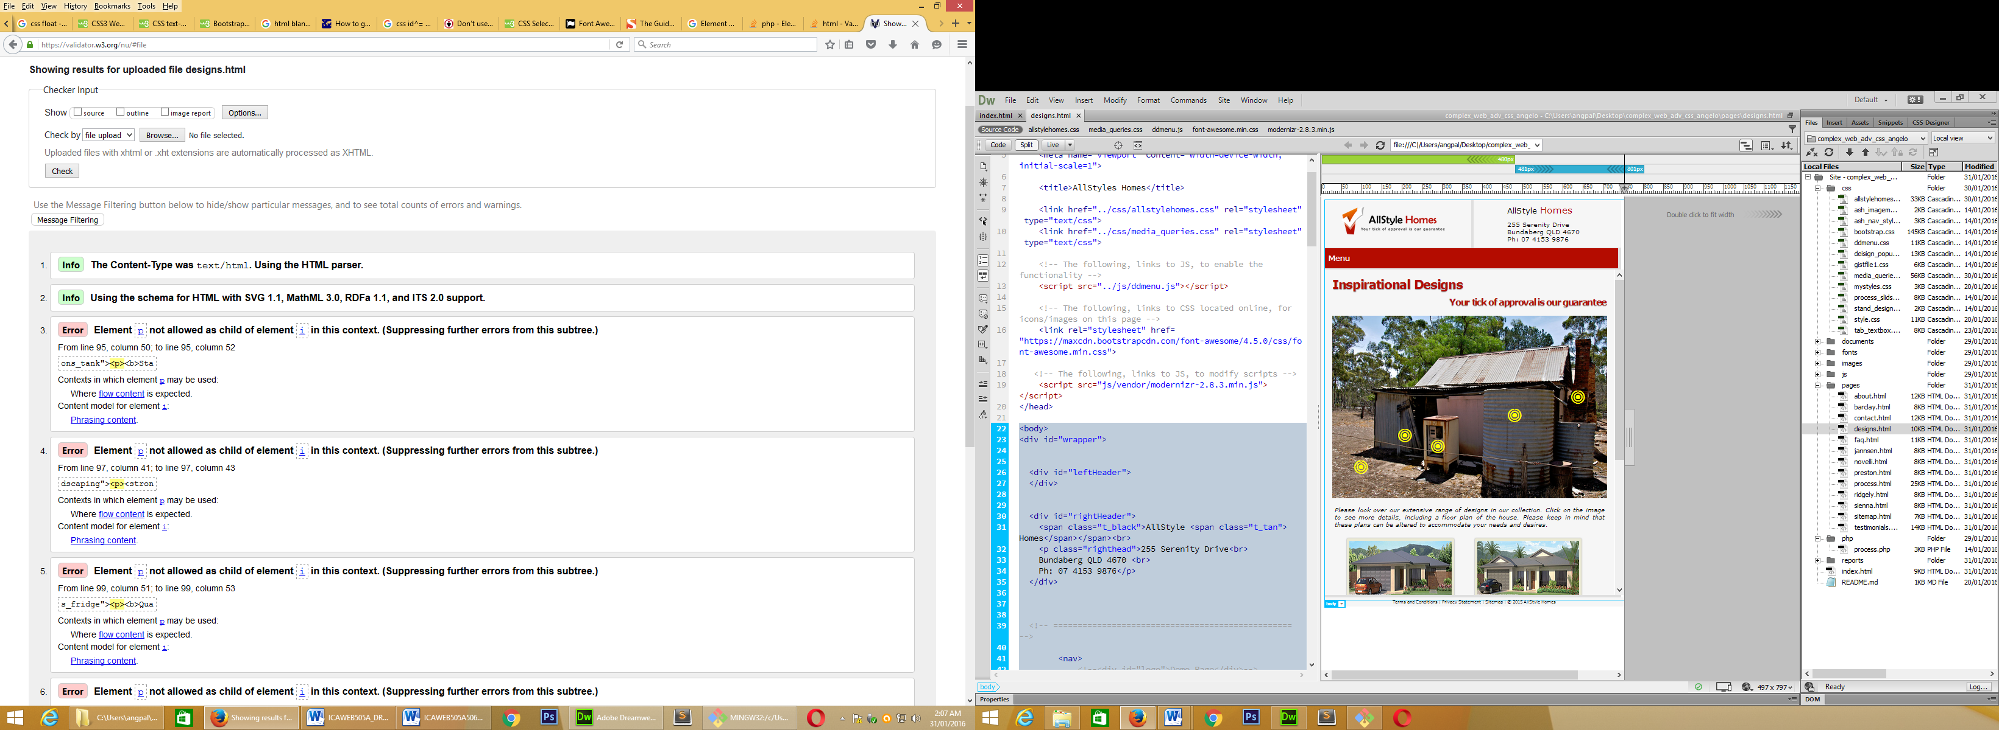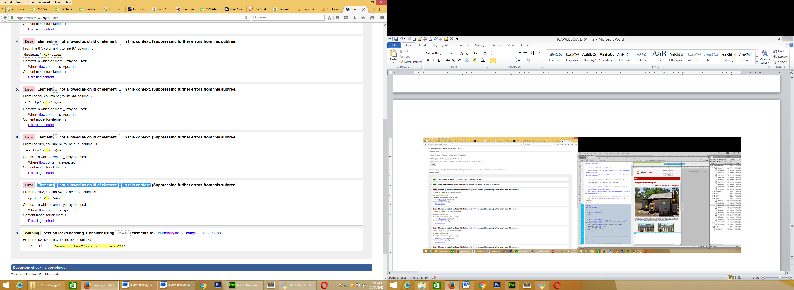

Solutions:

1 to 7 – The problem was that there was a <p> element inside an <i> element. The solution was to change the <p> element into a <span> inline-element with a class (ie. <span class="iIMText">). I then had to go and change the CSS, associated <p> (ie. replaced p with span.iIMText)

8 – Warning was unnecessary. A <h5> heading was added.

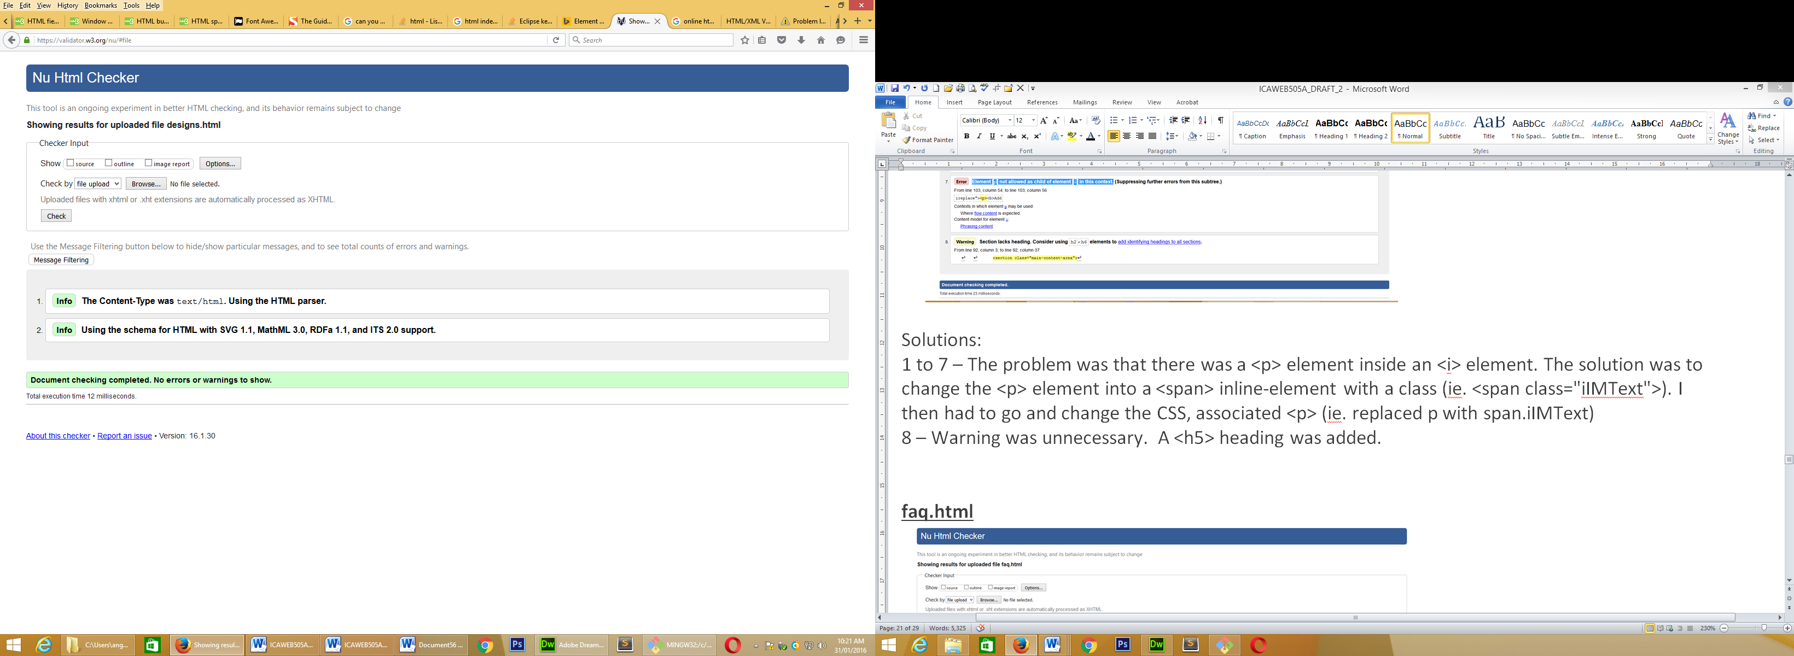

**faq.html**

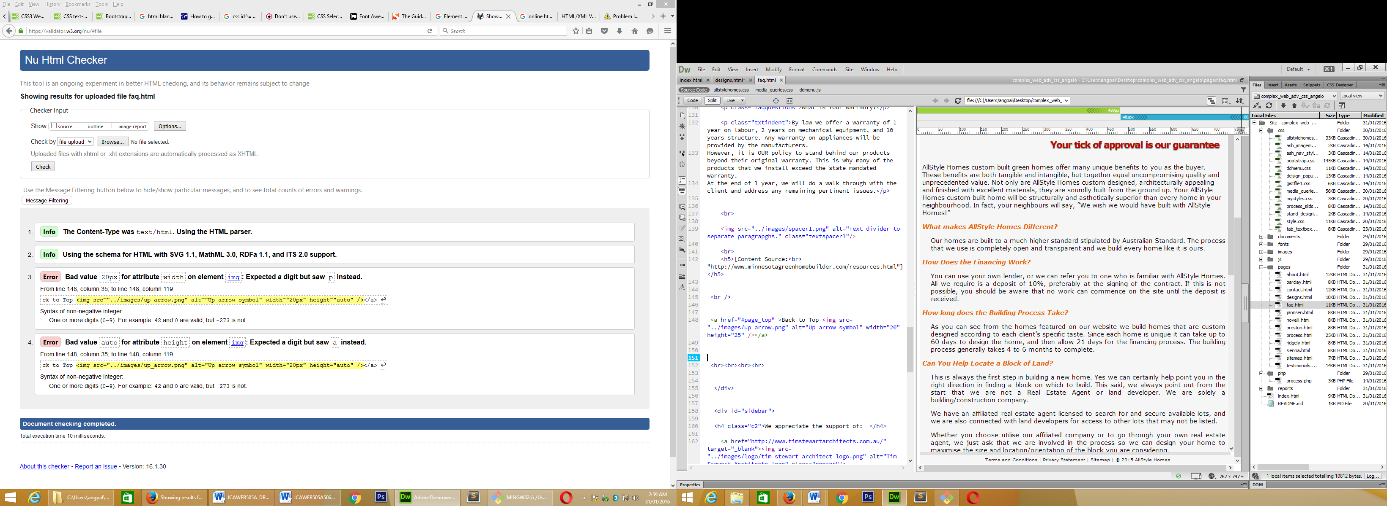

Solutions:

3. Corrected by removing “px”

4. Corrected “auto” replaced with a numerical figure

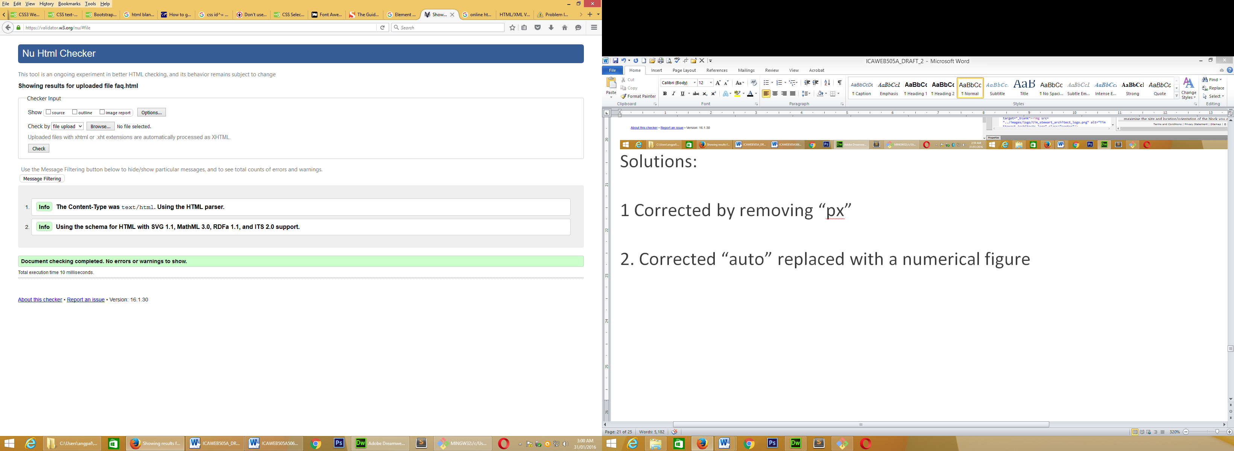

**jannsen.html**

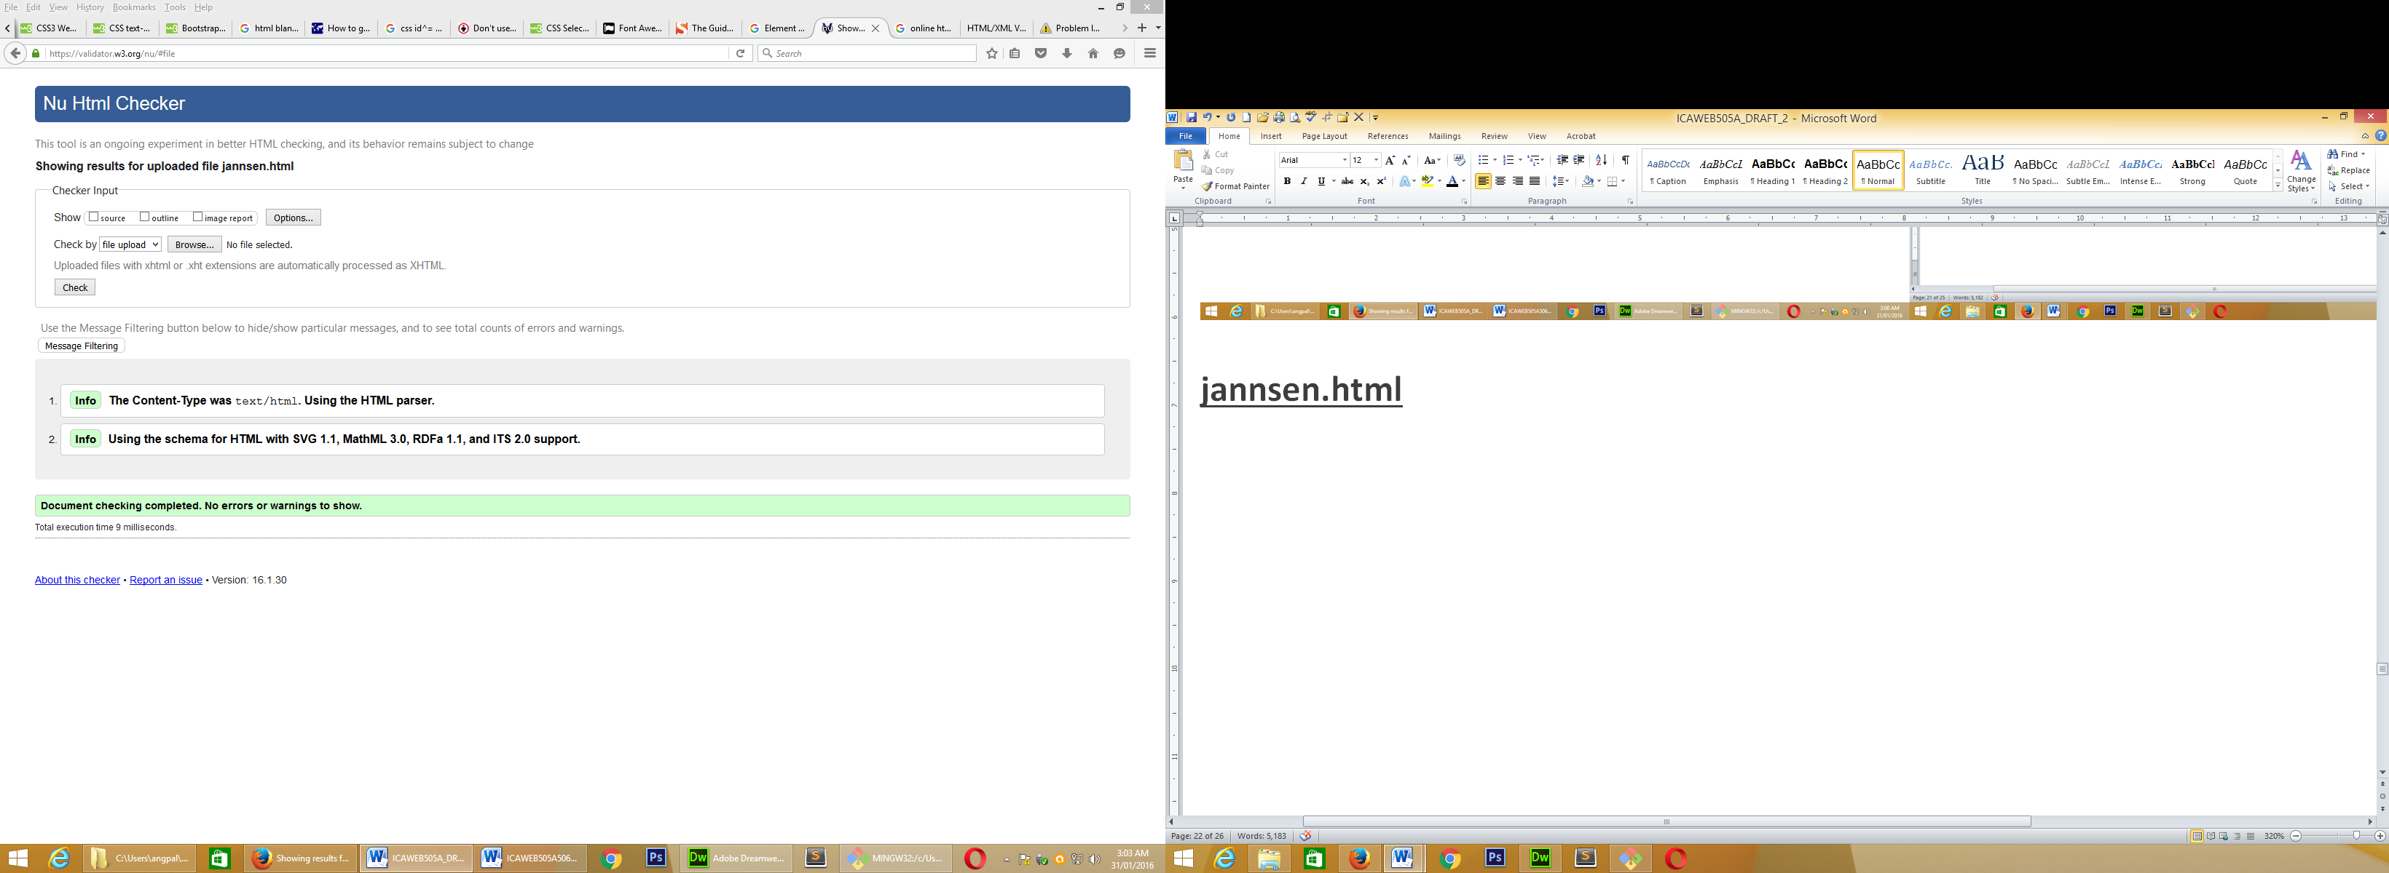

**novelli.html**

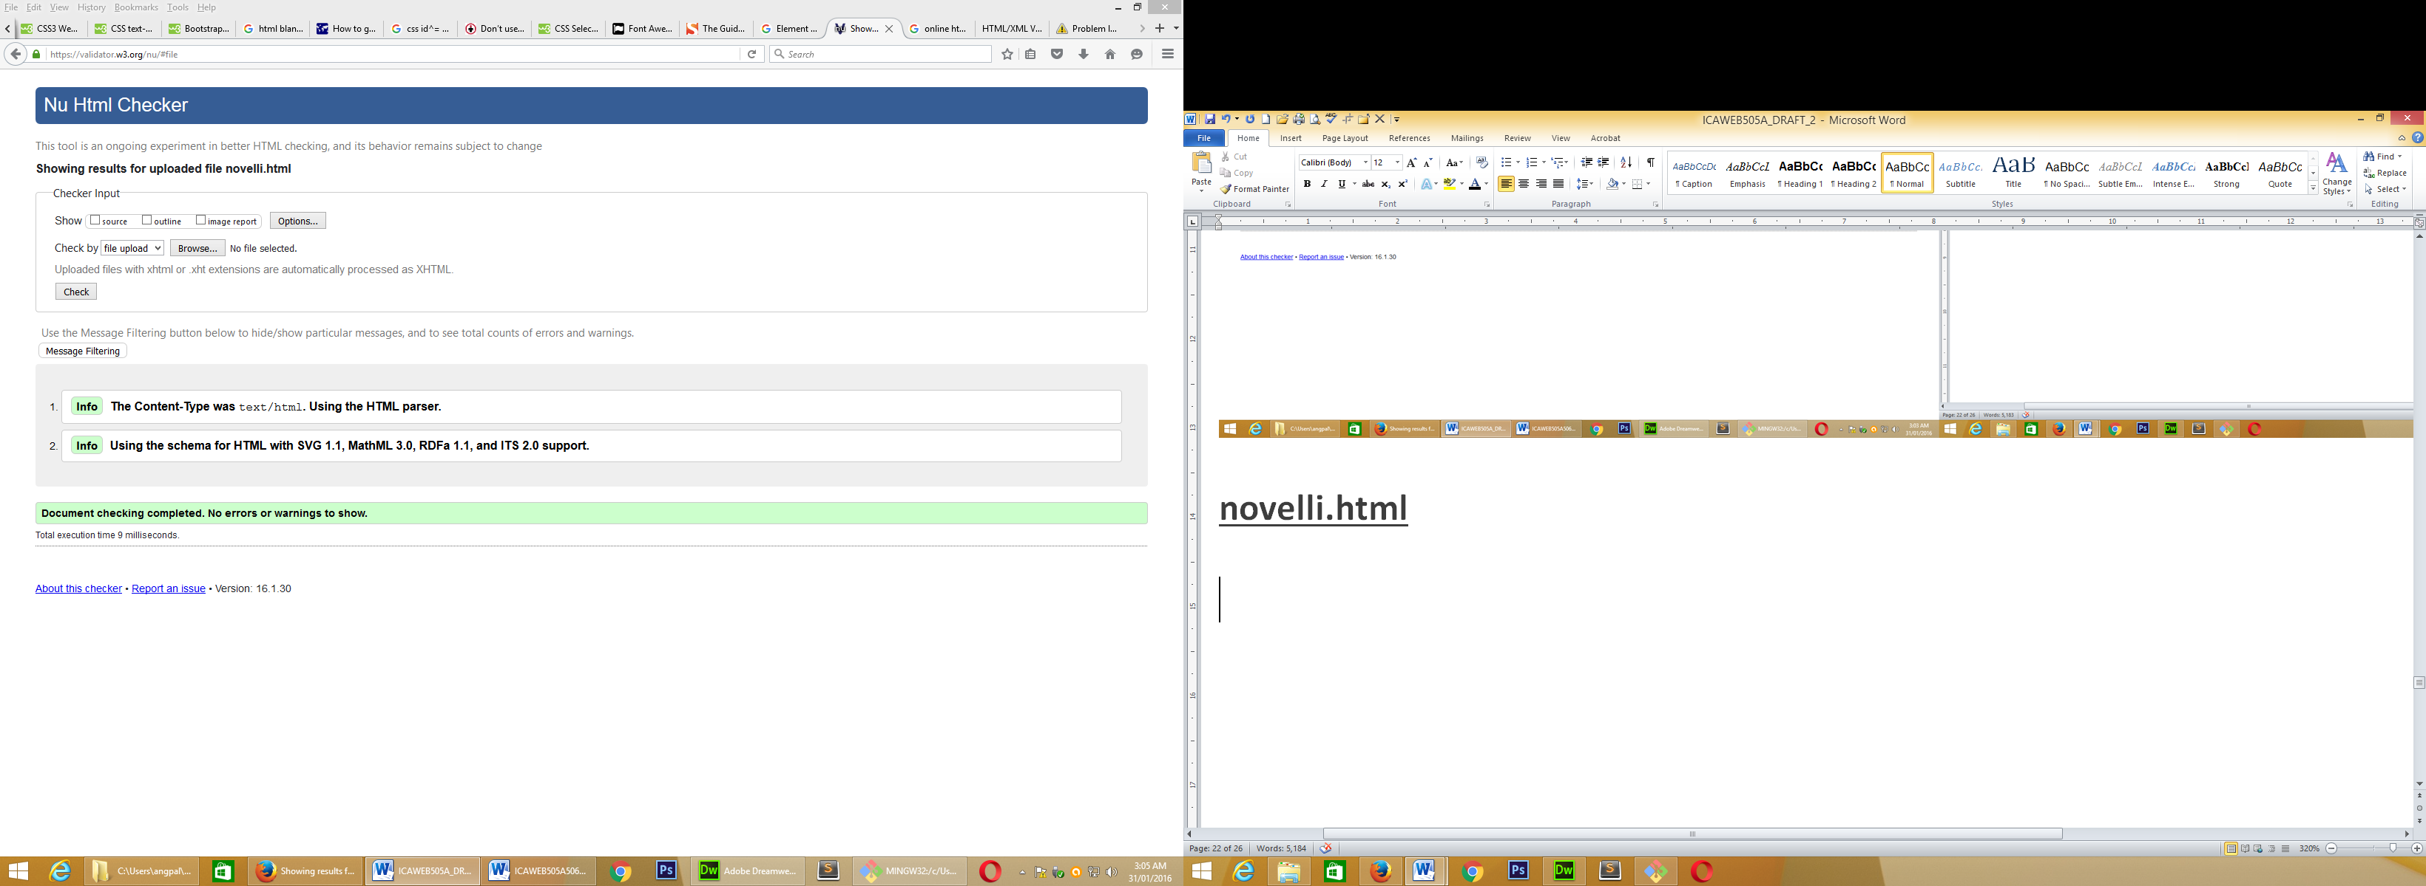

**preston.html**

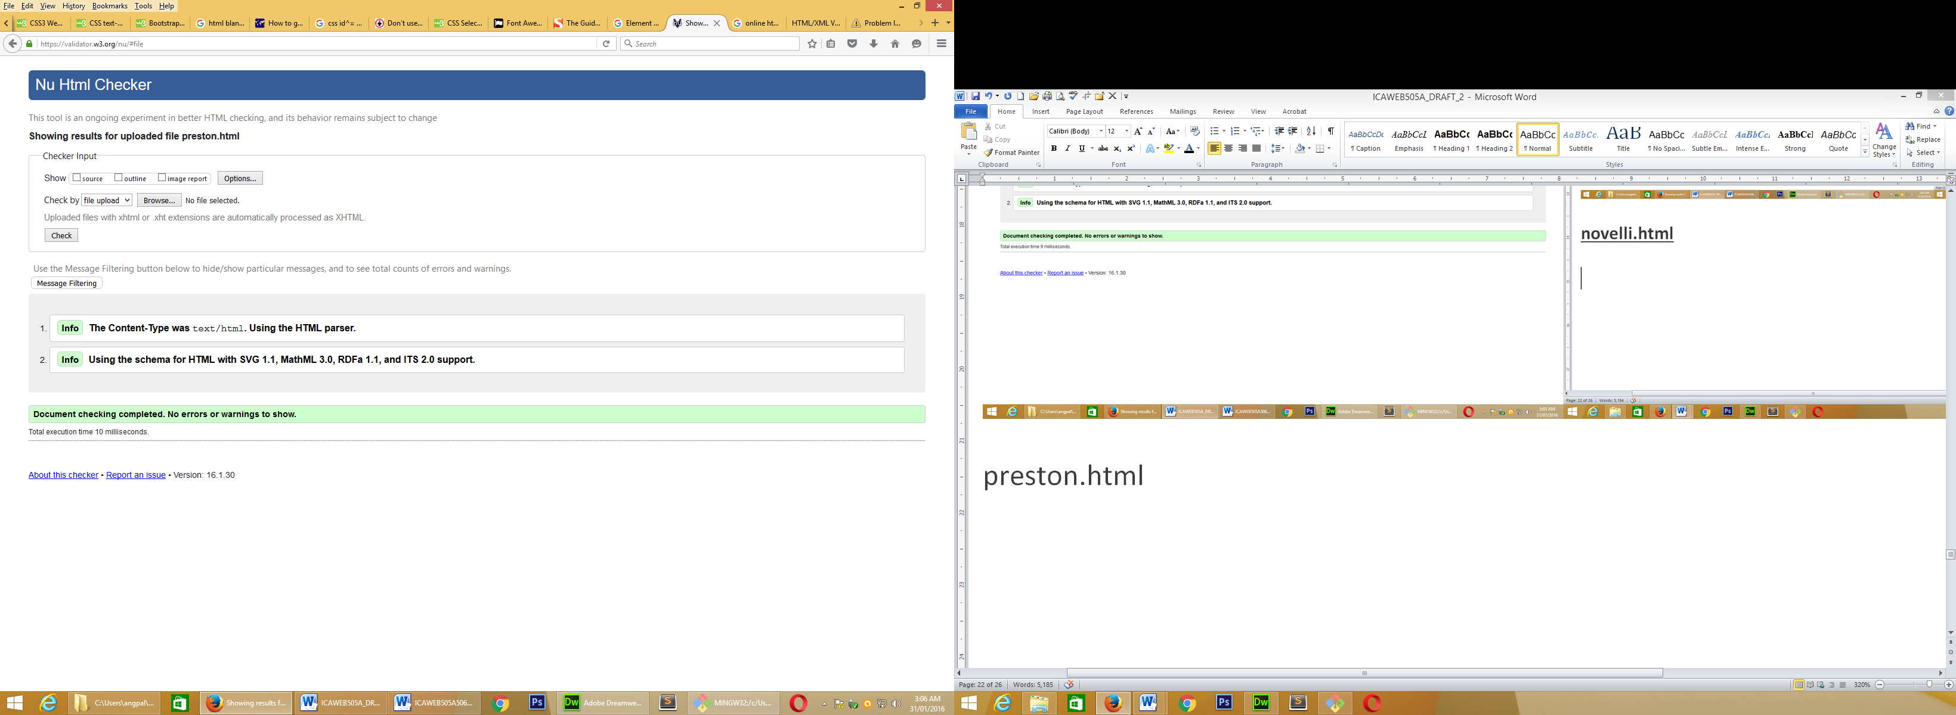

**processes.html**

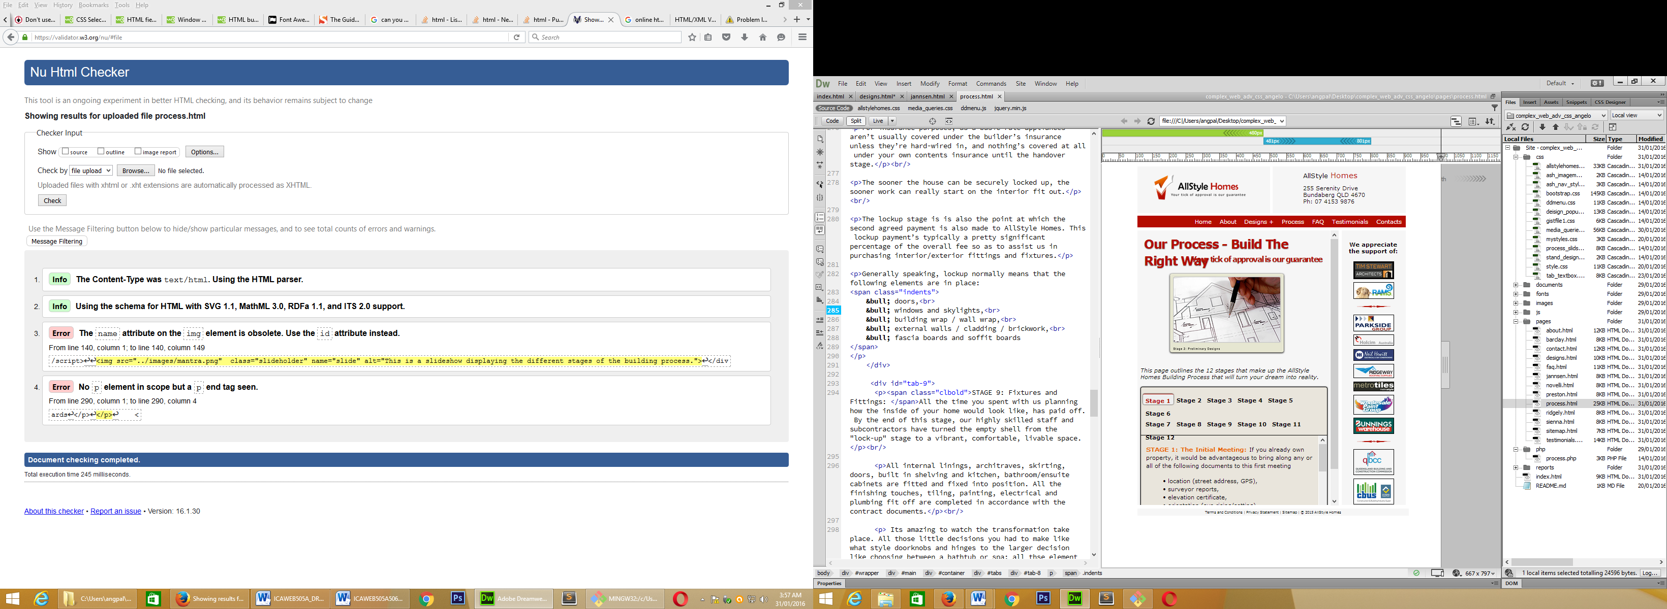

Solutions:

3. Changed name= “slide” to id=”slide”

4. Validator claimed there was a missing start tag. The problem was in fact that there was a <p></p> within a <p> tag which is not allowed in HTML5. I replaced inside <p> with a <span>.

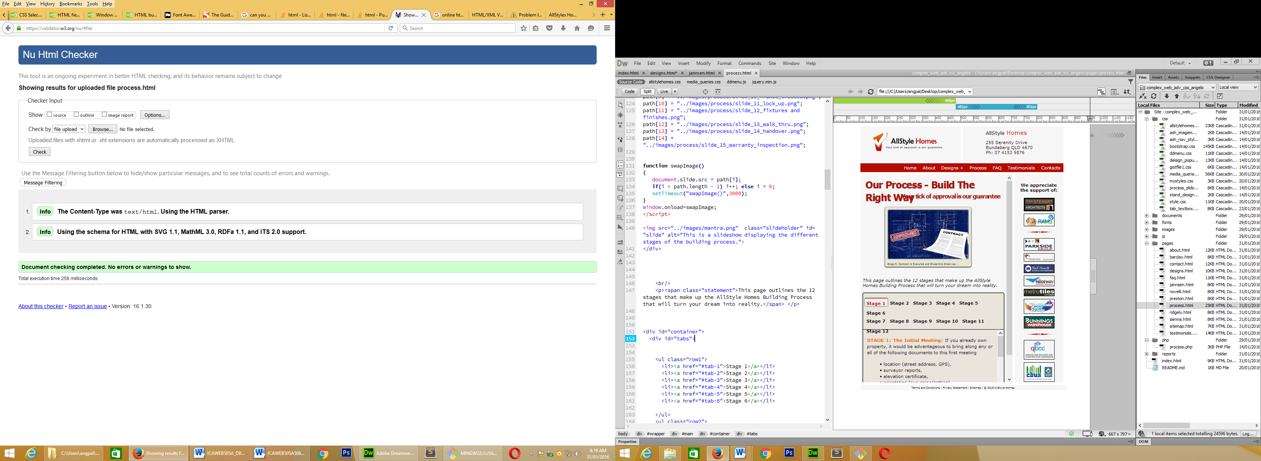

**ridgely.html**

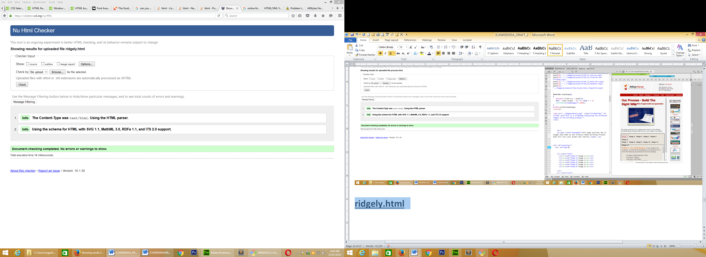

**sienna.html**

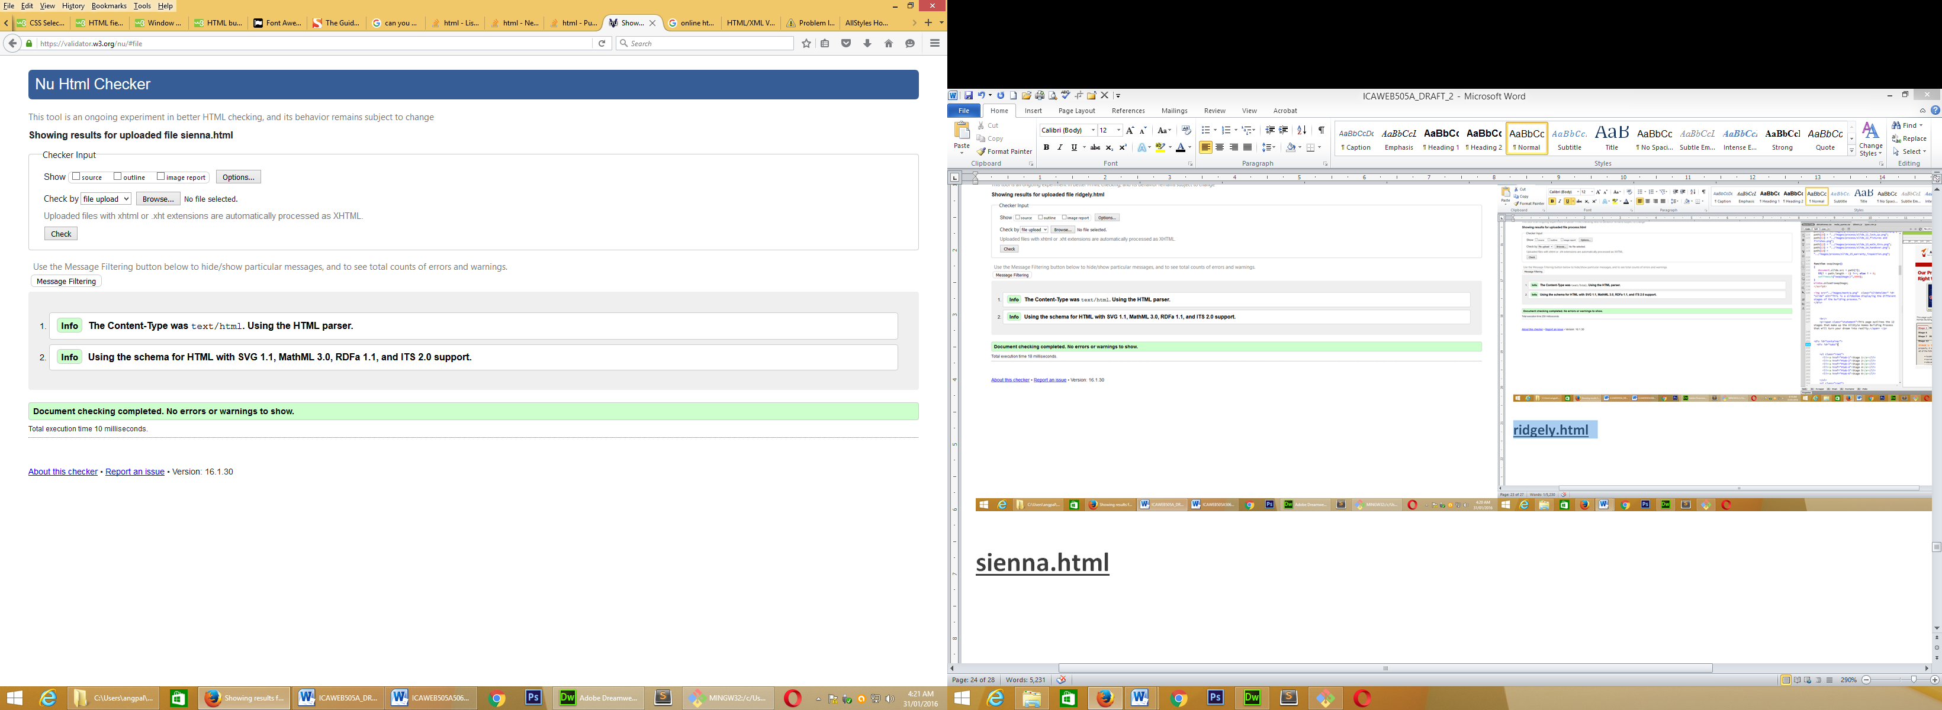

**sitemap.html**

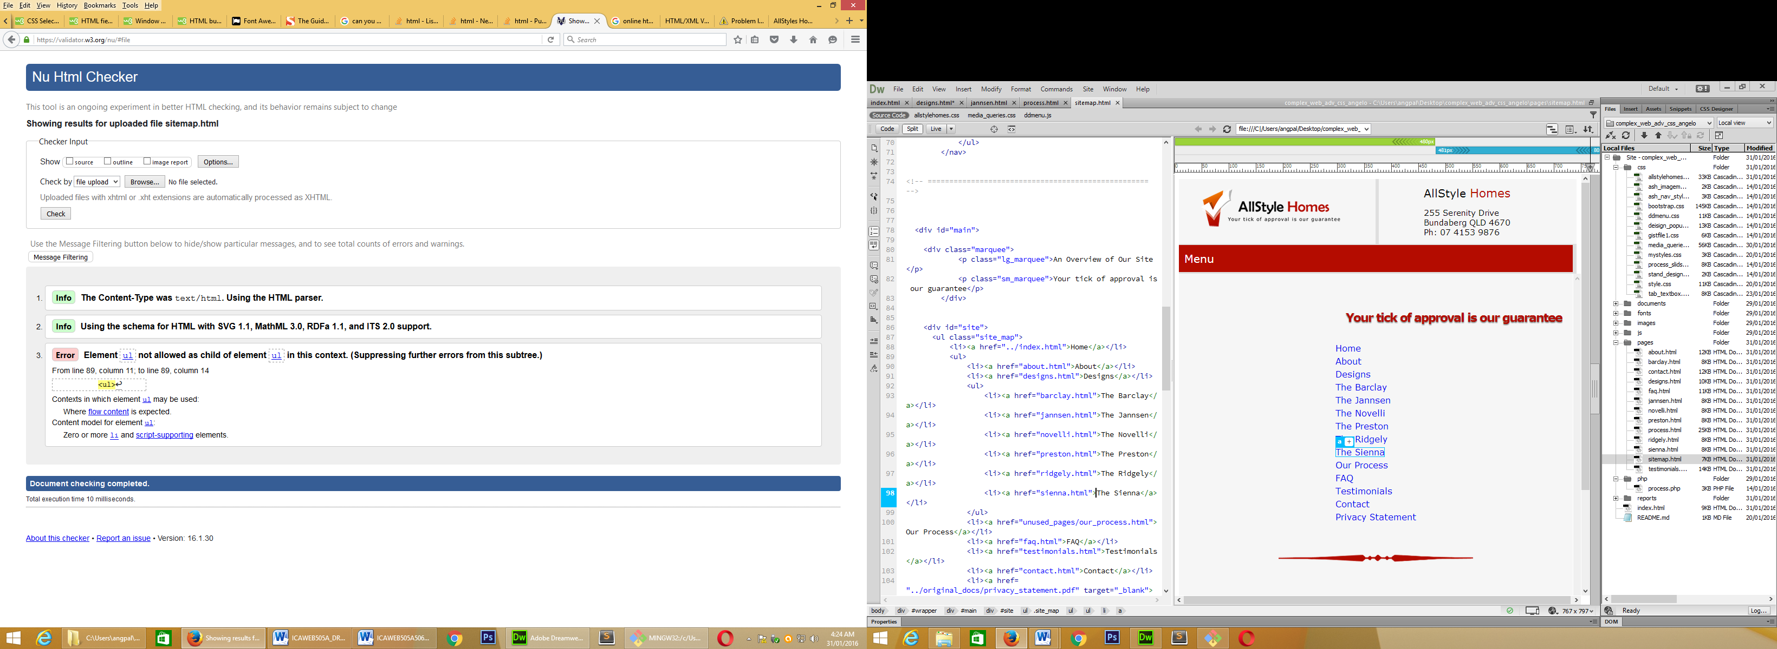

Solution:

3. The HTML code involved nested, unordered lists. This code needed to be revised, specifically the manner in which <ul> and <li> tags were opened and closed to accept the nested/sibling lists.

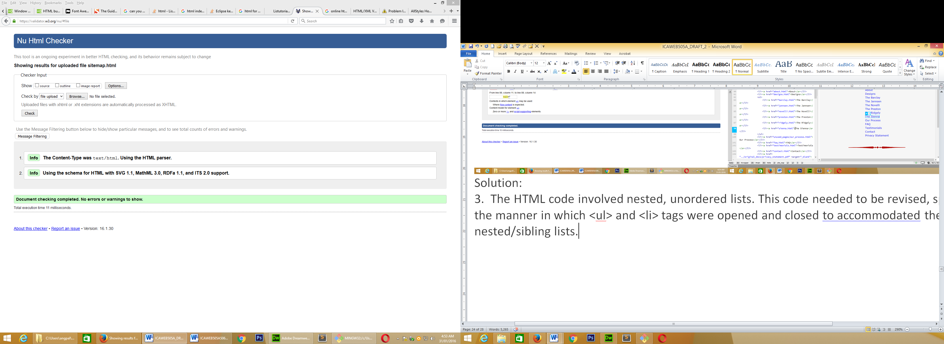

**testimonials.html**

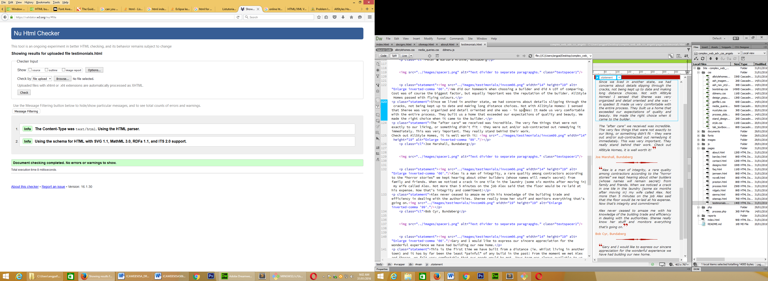

**allstylehomes.css**

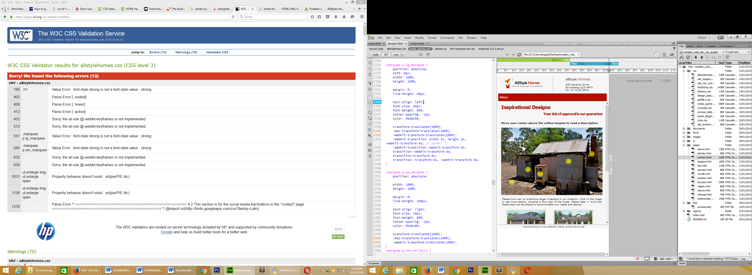

Solutions

403, 408 and 413 – On inspection discovered a space had been left after the colon (:). Space removed and problem solved

452, 513, 632 & 639 – Issue unresolved. The animation still functions correctly.CSS syntax is correct as per W3School examples. Online forums suggest to ignore it

180, 557 & 580 – The line of code was changed to “font-weight=700;”

1031, 1136 & 1378 – URL links were removed (Remains of pieces of code that were trialled during development)

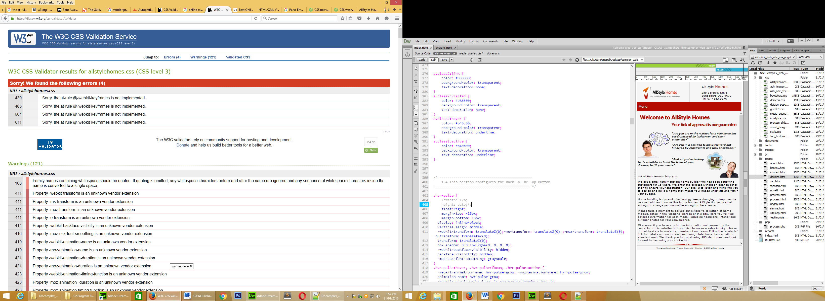

**media_queries.css**

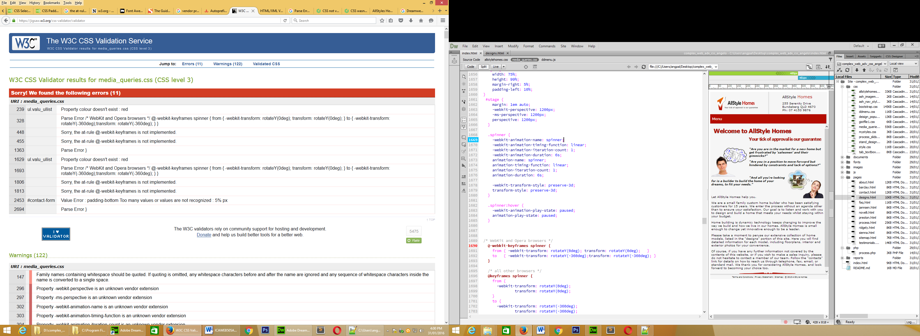

Solutions:

239 & 1629 – Spelling error (colour/color)

2453 – Typo error . Error corrected.

328 & 1693 – I suspect that these errors might be related to the other keyframe issue

448, 455, 1806 & 1813 – As with the last CSS validation, the animation works correctly, but there is no resolution

1363 & 2694 – Insufficient information to locate faulty/incorrect code

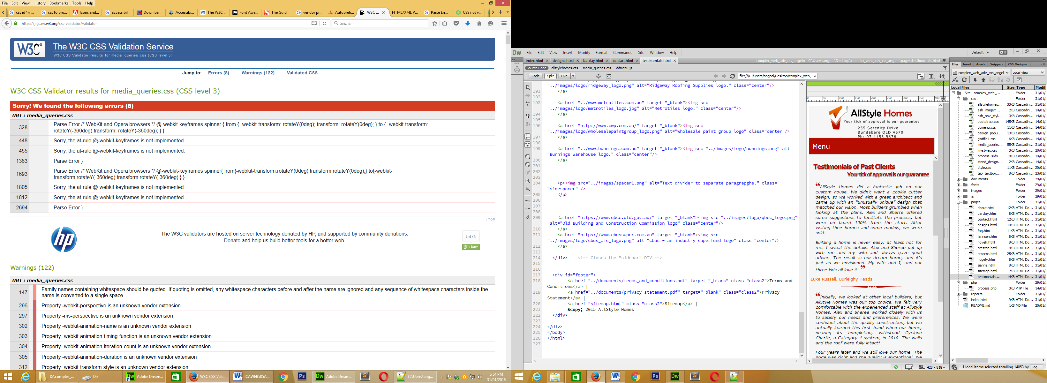

1. Test the website to ensure it meets accessibility standards including visual impairment (submit these as screen shots)

All Style Homes acknowledges and welcomes the expectation to make their website accessible to people with disabilities. Every effort has been made to address the requirements outlined in WCAG2.0.

Some basic features have already been implemented. These include:

* Font size of at least 12px has been maintained throughout the site. Headings have been considerably larger
* Font type has also been considered. Verdana has been used throughout the site because of its simple, clean/clear lines and high readability. Verdana is classified as a san serif or simply sans typeface. This category does not have the small projecting features called "serifs" at the end of strokes. These additional features make it difficult for people with visual impairment to focus and distinguish letters. As such, these fonts are not incorporated in our site.
* Apart from the banner or marquee on each page, no other text is animated; thus enabling uses with visual impairment to be able to focus on the text
* Our site contains two animated features – the rotating logo on the home page and the sliding marquee on every page. Both of these animated feature are limited to one iteration. The purpose for this has been top minimise the distractive qualities of animation.
* The layout of the page has been kept, simple and uncluttered. All textual information has been restricted to the main body. This body is a single area, allowing text to flow continuously in one direction. On our site we do not use columns or tables. All of these factors are all geared toward allowing electronic readers to transmit the information without being disjointed or incomplete. It is worth noting: on our process page, the use of the tabbed-textbox will be reviewed before our next website “renovation”.
* All images on this site have the alternative text incorporated into the HTML coding. Every effort is made to ensure that this text is descriptive and informative.
* Our site is responsive. As well as allowing for small hand-held devices, it also allows for large screen monitors, televisions and projections.
* The navigation system has been kept simple. Apart from our Designs Page, which has a nested/drop-down menu, all other pages are visible on a single level of our menu bar. This allows users with quick and easy identification of where they need to go and does not rely on a strong visual memory of where that menu button was, buried several layers down
* In the near future we would like to look into adding audio based content with the use of audio/video film clips, pre-recorded captions or voice-overs, etc.

Below are some screen grabs of an accessibility assessment made on our homepage. This assessment was undertaken online at <http://wave.webaim.org/report#/>. The result was a visual representation of the compliant and non-compliant sections of our page. As expected, the marquee/slide is an area of concern, but as we have already explained, we have minimised the number of iteration (movements). Another questionable feature was our links to off-site pdf document. While in itself that is acceptable, the fact that we do not provide a reader on site, or a link to where a reader is available for user or to download, is disadvantaging users without a pdf reader.

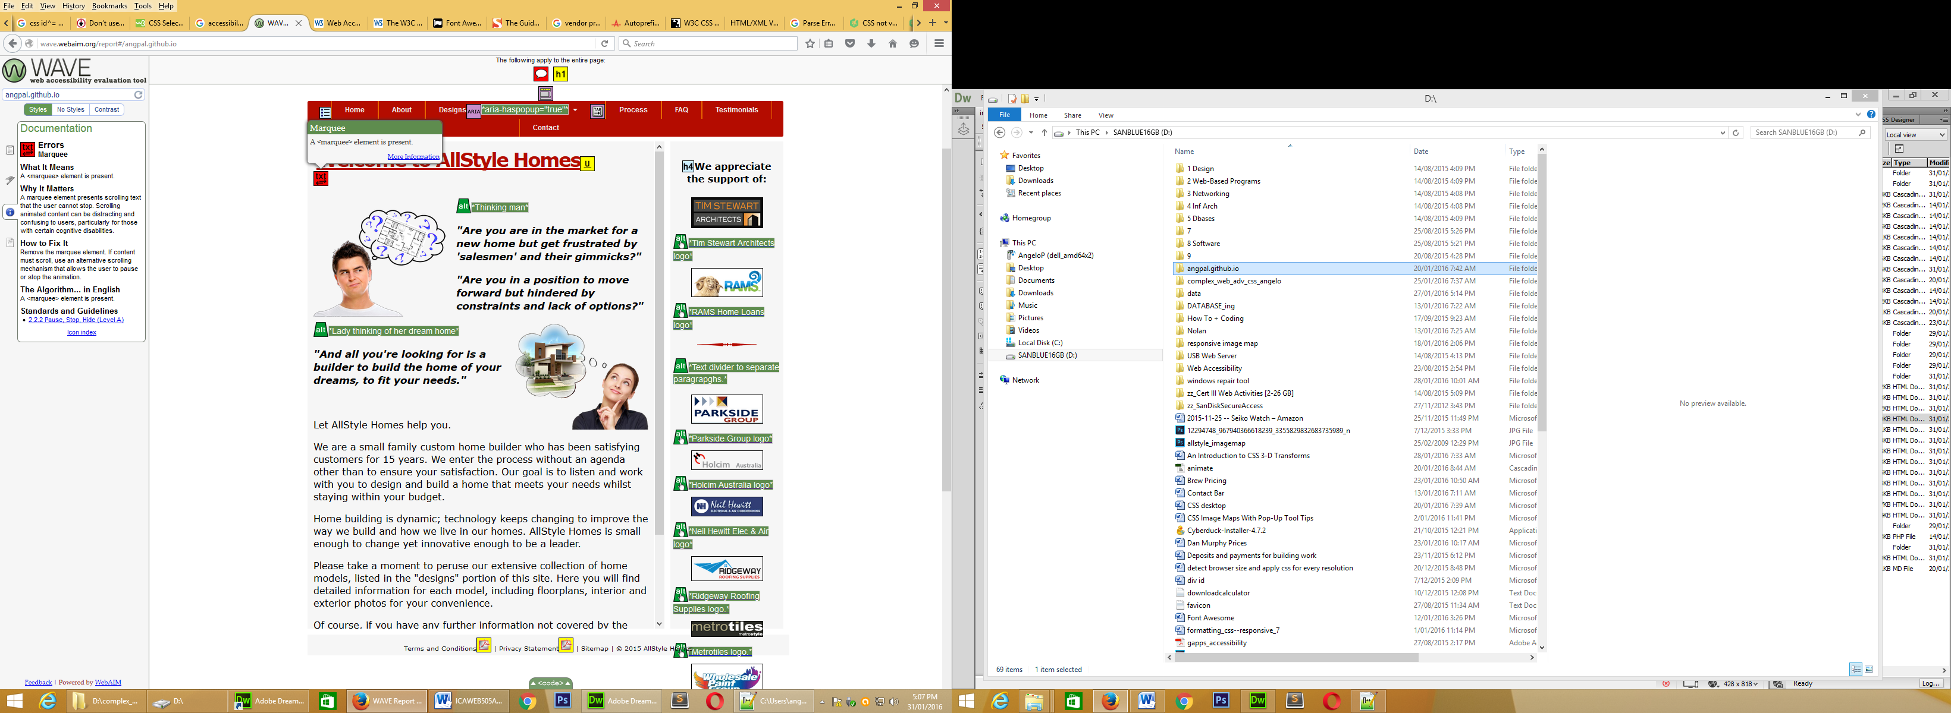 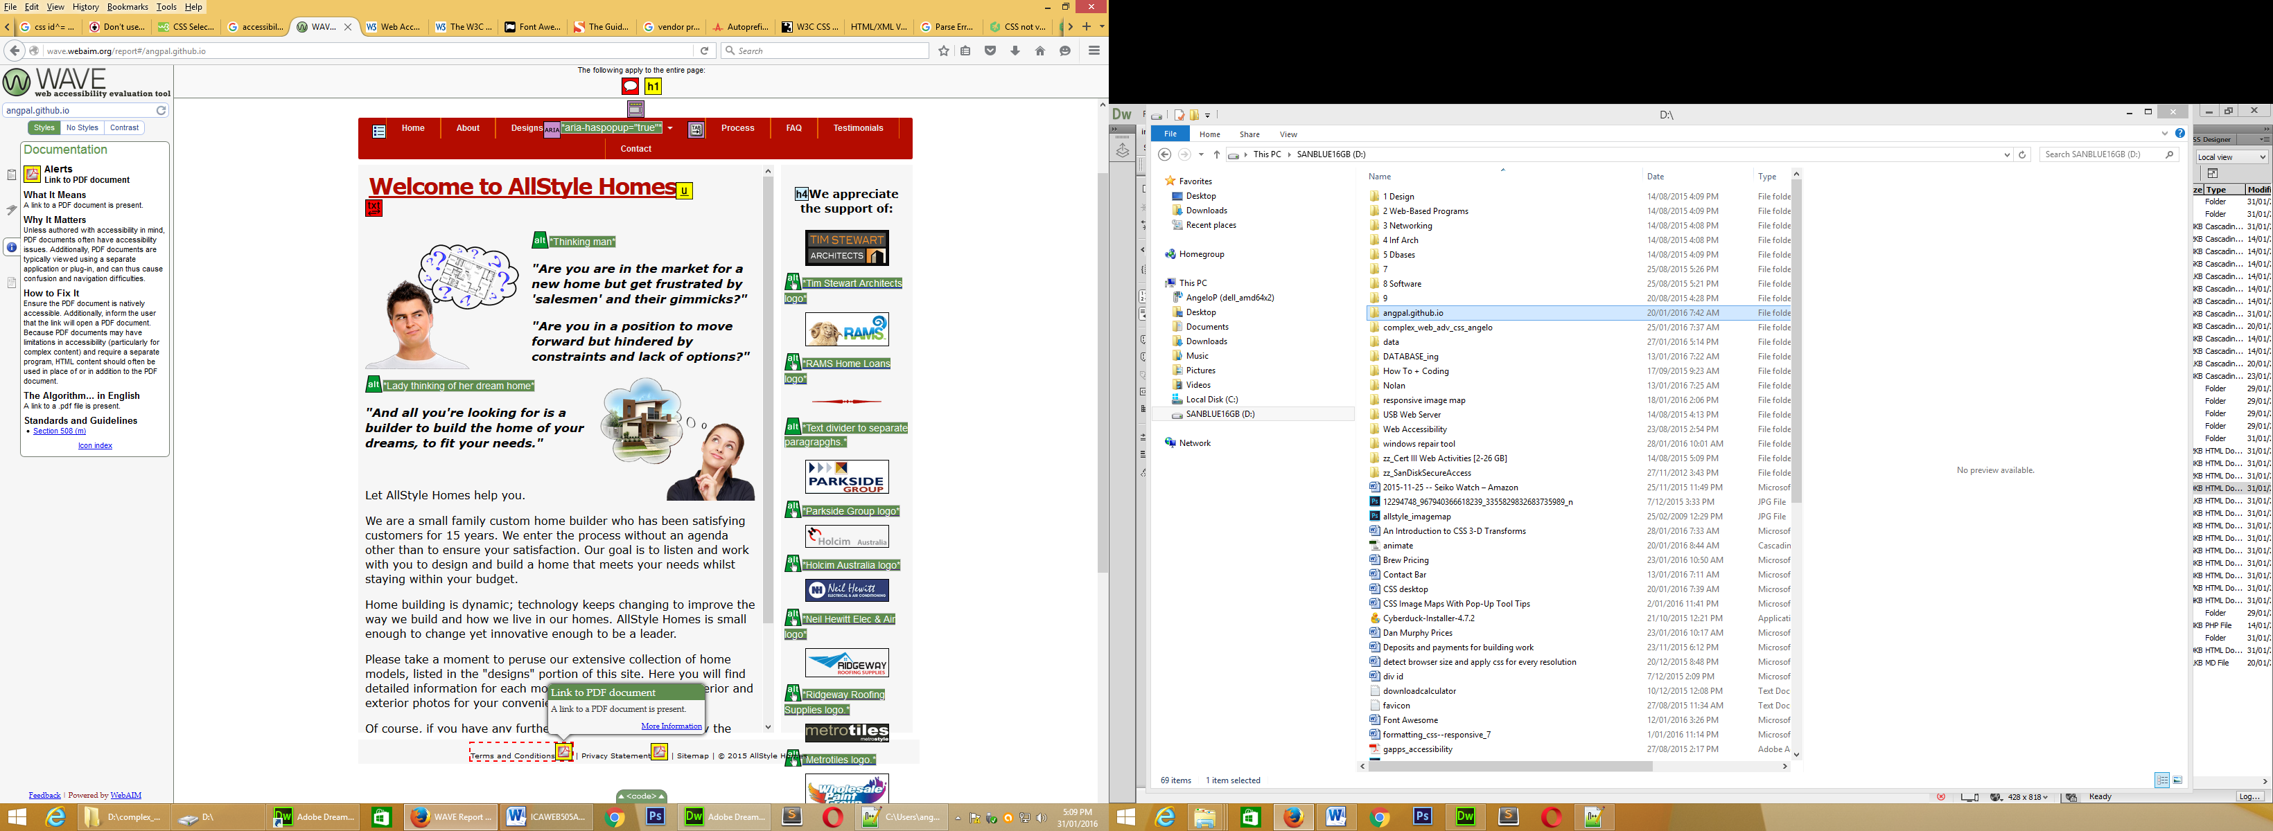 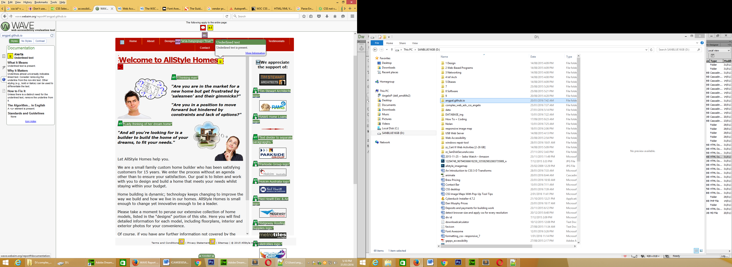

1. **Identify any issues with the site and document your rectifications**

In question 4, we undertook a Validation Test of our HTML and CSS. This identified errors and issues. The strategies we undertook were recorded before our site was re-tested

In question 5 we examined how accessible the website is to users with disabilities. This examination lead to a some future considerations, regarding accessibility, which will be made in the near future.

There are other recommendations I would like to put forward

* Users accessing the website from there computer/laptop, will quickly notice the large area of white space, either side of the content are. In short, the content area is too narrow at only 800 pixels wide. One option would of course be to go full screen but the follow-on affect would be the difficulty faced fitting all that additional content onto a hand-held device. My recommendation would be to increase it 1080 pixel, but ensure it is still responsive to accommodate people with older and smaller monitors.
* My next recommendation would be to move the sidebar. Presently the sidebar disappears for tablets and smartphones. Since I understand the importance of advertising, I would suggest relocating such advertisments to the lower sections of the screen such as the footer.
* The third recommendation would be to increase options for customers to communicate with the company and vice-versa. The contact page should provide opportunity for customers to make a comment, ask a question, seek clarifications or organise an appointment. In addition to social media a comments section, people could have the option to sign up to receive newsletters and/or promotional material

**Project Resources**

Below are a number of resources needed to complete this project. Located on the Diploma Shared Drive.

* Design Brief - this document describes the requirements of the project (PDF file 499Kb)
* Wireframe - full size copy of page wireframe (PDF file 138Kb)
* Site Structure - full size copy of site structure and navigation (PDF file 86Kb)
* Logos - zip file containing various formats of client logo (ZIP file 95Kb)
* Imagemap image - source image for creating CSS imagemap (JPG file 295Kb)

You will need to submit

* The following should be included in your uploaded zip file (please ensure that there are no additional files):
* your completed website, after testing and required corrections. (Tasks 1, 2 & 3)
* your report on the implementation of CSS (Task 2)
* your testing report (Task 3)

**End of assessment**